

***Bolt Air***

***B5 Condor Supersonic Business Class Jet***

**Team Members:**

Prescott Rynewicz

Jordan Robertson

Janelle Rogers

Lukas Kramer

Quang Nguyen

**Professor:** O. Bendiksen

**Date:** February 16, 2017

**TA:** *Dylan Neff*

Part. : *Anthony Yoon*

Table of Contents

List of Tables 3

List of Figures 4

Introduction 5

Background 6

Aircraft Layout and Design 8

Weight and CG Estimates 8

Aircraft Layout and Design 13

Stability and Control 19

Introduction 19

Moment Coefficient and $CMalpha$ Calculations 19

Procedure and Trim Calculations 21

Conclusions 24

Future Work and Improvements 24

Subsonic Aerodynamics 25

Drag Calculations 25

Conclusion 29

Supersonic Aerodynamics 31

Takeoff and Performance 35

Takeoff 35

Ground Roll 35

Rotation, Transition and Climb Distance 36

Performance 38

Conclusions 39

Conclusion 40

Future Work 41

References 43

Appendix A 44

# List of Tables

1. Design Specifications and Requirements
   1. Wing Loadings
2. Aircraft Weight Breakdown
3. Initial Aircraft Weight Estimates
4. Aircraft Loading Conditions
5. Aircraft Subsonic Stability
6. Aircraft Supersonic Stability
7. Aircraft Lengths and Volumes
8. Center of Gravity Placements
9. Fuel Tank Parameters
10. Interior Design Specifications
11. Constant Stability Values, independent of CL
12. Values for subsonic Cruise Stability
13. Results from subsonic cruise stability
14. Values for supersonic cruise stability
15. Results for supersonic cruise stability
16. Future Work Values for Stability
17. Frontal and Wetted Areas of Aircraft
18. Drag Interference Factor
19. Drag Form Factor
20. Skin Friction Coefficient
21. Subsonic Induced Drag
22. Subsonic Total Drag
23. Supersonic Parasite Drag
24. Supersonic Induced and Wave Drag
25. Supersonic Total Drag

# List of Figures

1. Top View Drawing of Aircraft
2. Front View Drawing of Aircraft
3. Right View Drawing of Aircraft
4. Interior Design Layout
5. Stability Force Diagram
6. Moment CG plots

# Introduction

This year’s UCLA Aerospace Engineering Senior Design project is to design an original model of a Supersonic Business Jet (SSBJ) capable of meeting a strict set of design parameters including range, speed, and altitude. The Jet needs to be able to travel a range of 4,500 nmi (approximately the distance from L.A. to London), capable of both subsonic and supersonic cruise with the highest Mach number being 1.8, and cruise at a ceiling of anywhere between 41,000 and 519,000 ft. On top of that, there are guidelines for cabin seating requirements, including one 8-passenger configuration to give maximum range and one 12-passenger arrangement for a maximum seating configuration (which would also require more fuel because of the increased payload). However, for the midterm report, while still instructed to perform mathematical calculations for both seating arrangements, it was only required to create an interior design layout for the 12-person configuration.

We followed a specific design process from the very beginning of choosing a MTOW, to the very end when it came down to carrying out performance calculations, thrust requirements, and a final engine selection capable of meeting all requirements. Each individual step required multiple iterations within itself, and great caution had to be taken when deciding to change a parameter, knowing that that change would carry through all subsequent assumptions and calculations. Proficient MATLAB coding capabilities were required to carry out the lengthy calculations, and each member of the group contributed at least one or more original codes to the project.

The specific design process that we used was that of the “Suggested Design Steps – Midterm Report,” by O.O. Bendiksen. After the MTOW and fuel calculations were squared away, we were able to move forward with center of gravity and stability calculations, as well the technical drawings and interior design. Next, trim calculations and subsonic and supersonic calculations were carried out, which mainly consisted of drag determinations. After that, engine thrust calculations were performed ensuring the aircraft was able to meet a supersonic Mach number of 1.6 at a cruise altitude between 41,000 and 51,000 ft. However, with our existing design of a 2-engine configuration, it was determined that we were short approximately 4,000 lbs of thrust to meet the minimum altitude of 41,000 ft. Proceeding upwards in altitude, calculations showed an even larger deviation between thrust needed and thrust available, which tells that we will we will be required to add a third and possibly even a fourth engine during the second part of the course after the midterm report. The best engine available for our existing calculations and configurations proved to be the BJ220.

What follows in this report is our preliminary design process, featuring steps taken, calculations made, and resulting values. In the end, we discuss our plans for future work and corrections that will be made after the midterm report.

# Background

|  |  |
| --- | --- |
| Crew | 2 Pilots plus one executive steward(ess) |
| Cabin Seating | 8 seats in executive (max. range) configuration; 12 in max. seating configuration |
| Range | 4,500 nautical miles at Mach 1.6 |
| Supersonic Cruise Mach Number | 1.6 – 1.8 |
| Subsonic Cruise Mach Number | 0.90 – 0.95 |
| Maximum Operating Mach Number | Mach 1.9 |
| Cruise Altitude | 41,000 – 49,000 feet (climb cruise) |
| Service Ceiling | 51,000 feet |
| Initial Cruise Altitude | 41,000 feet |
| Payload with Maximum Fuel | 2,000 feet |
| Takeoff Climb Speed V2 (SLSD, MTOW) | TBD, but should not exceed comparable subsonic business jets by more than 20% |
| Approach Speed (SLSD, MLW) | TBD, but should not exceed comparable subsonic business jets by more than 20% |
| Rate of Climb | 3500 fpm at SLSD conditions and max. gross weight. Time to climb to 37,000 feet should not exceed 20 mintues. |
| Takeoff Distance (to clear 35 ft obstacle) | 6,000 feet (SLSD, MTOW) |
| Additional Requirements | Aircraft must be stable in pitch without the use of active controls |

The first step in the design process involved a thorough analysis of competitor aircraft in order to develop a focused understanding of the airframe characteristics necessary to create a market-viable aircraft for our desired mission profile. We found the most market potential for an 8-12 person long-range business jet and felt that market domination could be achieved by effectively introducing supersonic performance. Specifically, we examined the Dassault Falcon 5X, the Gulfstream G500, the Bombardier Global 5000, the Aerion AS2, and the Spike S 512. The first 3 aircraft are subsonic and can be surpassed by matching their luxury and adding supersonic capabilities. The latter 2 aircraft are both also proposed supersonic business jets, but they have faced several design problems, most notably being propulsive requirements, so overcoming them will require a mix of superior luxury, superior performance, and reaching market first. Based upon the existing market, meeting the following requirements will provide our aircraft with a high likelihood of market success:

**Table 1: Design Specifications and Requirements**

Beyond helping to establish desired performance parameters, researching other aircraft was also important to informing our initial aircraft dimension estimates. MTOW data for the researched aircraft combined with wing area estimates gave us examples of reasonable wing loadings, from which we were able to comfortably select a slightly more aggressive initial wing loading of 110. This first design choice was then able to drive dimensional characteristics, such as wing area, wing span, etc. Dimensional data for researched aircraft, as shown in appendix A, provided us with intuition to reasonably proportion the other dimensions of our aircraft, such as length and height, in relation to our wings. The next step was to estimate MTOW and group weights and the airframe group weight estimates for the researched aircraft, as shown in appendix A were useful for justifying our design decisions.

|  |  |  |  |
| --- | --- | --- | --- |
| **SSBJ** | **MTOW [lbs]** | **Wing Area [ft2]** | **Wing Loading [lb/ft2]** |
| Aerion AS2 | 90,549 | 1,350 | 89.63 |
| Bombardier Global 5000 | 92,000 | 1,021 | 90.10 |
| Dassault Falcon 5X | 69,600 | 779 | 89.34 |
| Gulfstream G500 | 76,850 | 950 | 80.89 |
| Spike S512 | 115,000 | 1,894.2 | 60.71 |

**Table 1.a: Wing Loadings**

After using reference data from the researched aircraft, we had a solid initial aircraft design that we could continue to develop and enhance. The physical design informed us of important information such as drag characteristics and thrust requirements. Revision were able to be made to properly stabilize the aircraft and weight, drag, and propulsive elements were altered (and are still being altered) to reach the desired performance characteristics. By meeting these requirements set forward by our research with the help of the knowledge gained from our research, we should be able to dominate the supersonic business jet market.

# Aircraft Layout and Design

## Weight and CG Estimates

Weight and CG estimates are the meat and potatoes of aircraft design. The initial estimates and iterations of the MTOW and group weights are crucial to maximizing the performance of the aircraft and meeting design specifications, as these weight calculations have a cascade effect and bleed through every succeeding step in the design process. Weight calculations largely determine the center of gravity, and center of gravity is tightly intertwined with stability calculations. Furthermore, stability and trim calculations cannot proceed until it is made certain that the CG of the aircraft has fallen within a reasonable range of the MAC. From there, static stability derivatives and all performance calculations can be made, along with engine selection and any pertinent corrections that need to be made to the initial design process. Another reason weight calculations are of such importance is because they are used in the range and endurance equations to determine fuel requirements. And altogether, different weight and fuel combinations must be mixed and matched together to ensure the center of gravity of the aircraft does not vary drastically under any one condition. The reason being is that in a real-life situation, there is a high variability as to what conditions the aircraft will experience whiling flying to its destination. Will it fly under maximum payload and maximum fuel conditions? What if it flies under minimum payload and minimum fuel conditions? The aircraft must remain stable in any scenario or disaster will strike for all on board.

We began our determination of the MTOW by testing different weight group scenarios and fuel requirements to meet the range of 4,500 nmi. We crafted a MATLAB code that would easily guide us through different configurations and return a number for fuel required. The amount of fuel required to meet the range was calculated using the Breguet Range Equation, shown below.

$$\frac{R}{a_{0}}=\frac{M\left(\frac{L}{D}\right)}{\frac{c_{tf}}{\sqrt{Ɵ}}}\ln{\frac{W_{0}}{W_{1}}}$$

The fuel required was then cross compared against volumetric constraints for fuel. If the maximum takeoff weight, MTOW, can be defined as

$MTOW=W_{empty}+W_{fuel }+Payload$,

this tells us that

$W_{fuel }=MTOW-(W_{empty}+Payload)$.

This is essentially saying that whatever weight is leftover after the empty weight and payload are stripped from the maximum takeoff weight is whatever is volumetrically available to be filled with fuel. We crafted a MATLAB code to easily guide us through different configurations and spit out a number for fuel calculated using both methods. Once we found a MTOW that made these two fuel calculations converge within a reasonable range, we kept that estimate and then moved forward with all other calculations. We ended up converging on a MTOW of 70,000 lbs. To estimate the group weights following from the MTOW, we referenced the group weight percentages based off of the Aerospace Caravelle VIR from Chapter 8 in Torenbeek’s text [9]. A summary of the group weights, along with the total airframe structure, the propulsion group, and the empty weight of the aircraft are given in Table 2 below. Note that the empty weight was not computed using the 55% estimation suggested in McCormick’s text, but rather by simply summing the group weights and the propulsion group. In this way, the empty weight of the aircraft actually turns out to be 40.6% of the MTOW.

|  |  |
| --- | --- |
| **Group** | **Weight [lbs]** |
| MTOW | 70000 |
| Wing Group | 9380 |
| Tail Group | 1239 |
| Fuselage Group | 7350 |
| Landing Gear | 3421 |
| Surface Controls Group | 1309 |
| Nacelle Group | 1001 |
| Total Airframe Structure | 23520 |
| Propulsion Group (not a part of Airframe Structure) (2 engines each at 2,445 lbs) | 4890 |
| Empty Weight (Airframe Structure and Propulsion System) | 28410 |

**Table 2: Aircraft Weight Breakdowns as a Function of MTOW.**

Furthermore, a list of estimates and calculations, in the order they were estimated or calculated, is given in Table 3 below.

|  |  |  |
| --- | --- | --- |
| **Parameter** | **Value** | **Units** |
| Wing Loading [W/S] | 110 | lb/ft2 |
| Maximum Takeoff Weight [MTOW] | 70000 | lb |
| Wing Area [S] | 636.364 | ft2 |
| Aspect Ratio [AR] | 7.202 | ** |
| Wing Span[b/2] (of one wing) | 33.848 | ft |
| Root Chord Length [Cr] | 13.539 | ft |
| Mean Aerodynamic Chord [MAC] | 10.008 | ft |
| Tip Chord Length [Ct] | 5.261 | ft |
| TSFC [Ctf] | 0.668 | 1/hr |
| Lift to Drag Ratio [L/D] | 4.289 | unitless |
| Speed of Sound at Cruise Altitude [a] | 963.228 | ft/s |
| Cruise Speed [V] | 1541.165 | ft/s |
| Speed of Sound at Sea Level [a0] | 1190.646 | ft/s |
| Ambient Temp at Cruising Altitude [Ta] | 216.65 | Kelvin |
| Standard Atmospheric Temperature [T0] | 288.15 | Kelvin |
| Air Density at Cruise Altitude [ρ] | 0.00238 | slug/ft3 |
| Number of Engines | 2 | unitless |
| Weight of One Engine | 2445 | lb |
| Total Weight of Engines | 4890 | lb |
| Payload | 2600 | lb |

**Table 3: Initial Aircraft Estimates. These estimates are based off of competitor aircraft. Competitor data can be found in the appendix.**

Following from the MTOW, we crafted another MATLAB code to perform center of gravity calculations for the four different loading conditions given in the project handout and checked that those loading conditions fell within a reasonable range of the MAC. The weight of the aircraft under the four loading conditions was calculated using the following methodology:

* *Load Condition I*: The weight of the aircraft in Load Condition I was taken to be the MTOW of the aircraft, as shown below.

$W_{aircraft I}=MTOW=70,000$ lbs

* *Load Condition II*: The weight of the aircraft in Load Condition II was calculated under two assumptions. The first assumption being that the maximum payload was 13 passengers (the 12 passengers in the maximum seating configuration along with 1 jump seat for the stewardess), and assuming that each of those 13 people would contribute 200 lbs, accounting for body weight and luggage. This 200 lb estimate is made in Chapter 7 of McCormick’s text. The second assumption, which was used to calculate the weight of minimum fuel, was that the aircraft must contain a 45-minute fuel reserve. This 45-minute fuel reserve requirement is given by FAA regulations. In order to calculate the weight of fuel required for 45 minutes, we utilized the famous Endurance Equation for a jet aircraft, shown below.

$$E= \frac{1}{c_{t}}\frac{C_{L}}{C_{D}}\ln{\frac{W_{o}}{W_{1}}}$$

We then totaled the empty weight of the aircraft, the weight of the 45-minute fuel reserve, and the weight of the payload, as shown below.

$$W_{aircraft II}=W_{empty}+W_{45-\min{fuel}}+W_{payload}=53522.835 lbs$$

* *Load Condition III*: Figuring the weight of the aircraft here was a rather simple calculation. We simply subtracted the 2600 lb payload (13 people each at 200 lbs as explained in *Load Condition II*) from the MTOW, as shown below.
$$W_{aircraft III}=MTOW-Payload=67400 lbs$$

* *Load Condition IV*: We simply added the weight of the 45-minute fuel reserve as calculated in *Load Condition II* to the empty weight of the aircraft, as shown below.

$$W_{aircraft IV}=W_{empty}+W_{45-\min{fuel}}=50922.83472$$

A summary of results is shown in Table 4 below, where the center of gravity is given as a distance from the nose, and the MAC was calculated to be 14.365 ft.

|  |  |  |  |  |
| --- | --- | --- | --- | --- |
| **Load Condition** | **Payload [lbs]** | **Fuel [lbs]** | **CG [ft]** | **CG Percent MAC** |
|
|
| **I** | Max | Max | 58.79 | 3.27 |
| **II** | Max | Min | 57.48 | -9.77 |
| **III** | Min | Max | 59.97 | 15.13 |
| **IV** | Min | Min | 59.13 | 6.73 |

**Table 4: Aircraft Loading Conditions.**

After the load condition, CG calculations, and CG Percent MAC calculations were performed, we then calculated the stability derivatives making use of yet another MATLAB code crafted by us. The results of the calculations are summarized in the tables below. All stability derivatives came out negative, which it should if the aircraft is to be trimmable.

|  |  |  |
| --- | --- | --- |
| **CL** | **CMcg** | **CMα** |
| 0.3 | -0.0636 | -1.0516 |
| 0.4 | -0.0886 | -2.1762 |
| 0.5 | -0.1107 | -2.8575 |

**Table 5: Subsonic Stability.**

|  |  |  |  |
| --- | --- | --- | --- |
| **CL** | **M** | **CMcg** | **CMα** |
| 0.3 | 1.6 | -0.0146 | -0.407 |
| 0.4 | 1.7 | -0.0218 | -0.222 |
| 0.5 | 1.8 | -0.0297 | -0.0623 |

**Table 6: Supersonic Stability.**

## Aircraft Layout and Design

The initial dimensioning lengths as well as two important volumes of our aircraft are displayed in the table below.

|  |  |
| --- | --- |
| **Parameter** | **Length [ft]** |
| Length | 90 |
| Fuselage Length | 42.17 |
| Tail Empennage Length | 29.9 |
| Engine Length | 13 |
| Nacelle Length | 14 |
| Nose Length | 17.82 |
| Width (Fuselage Diameter / Cabin Diameter) | 8.5 |
| Height | 23.3 |
| Total Wing Span (of both wings and diameter of aircraft) | 76.196 |
|
| Volume of Fuselage | 2392.93738 |
| Volume of Tail Empennage | 1696.676017 |

**Table 7: Aircraft Lengths and Volumes.**

The same MATLAB code that was used to calculate the four different centers of gravity of the aircraft was also used to determine the location of the main aircraft body features for the exterior design. A table summarizing the center of gravity placements is given below, where the distance indicated is the distance from the tip of the nose of the aircraft up to the leading edge of the respective component.

|  |  |
| --- | --- |
| **Component** | **CG Placement [ft]** |
| Leading Edge Wing Placement | 55.80 |
| Leading Edge Engine Placement | 63.00 |
| Leading Edge Nacelle Placement | 63.00 |
| Leading Edge Front Landing Gear Placement | 3.600 |
| Leading Edge Rear Landing Gear Placement | 40.500 |
| Leading Edge Fuselage Placement | 13.500 |
| Leading Edge Tail Empennage Placement | 59.99 |
| Leading Edge Vertical Tail Surface | 81.000 |
| Leading Edge Horizontal Tail Surface | 81.000 |

**Table 8: Center of Gravity Placements of Exterior Components.**

The fuel tank parameters are given in the table below, where we decided to utilize the wings and underbelly of the aircraft as fuel tank storage.

|  |  |  |
| --- | --- | --- |
| **Parameter** | **Value** | **Units** |
| Fuel Weight [Wfuel] | 24188.951 | lbs |
| Fuel Weight 45 Mins | 7711.786 | lbs |
| Jet Fuel Density | 49.943 | lbs/ft3 |
| Total Volume of Fuel Tank Storage Required | 484.331 | ft3 |
| Cross Section of Fuel In Center Tank | 10.180 | ft2 |
| Weight of Center Fuel Tank | 4818.530 | lb |
| Weight of Fuel in Both Wings | 19370.421 | lb |
| Weight of Min Fuel in Both Wings | 2893.255 | lb |
| CG Position for Center Fuel Tank | 62.57 | ft |
| CG Position of Wing Fuel Tanks | 60.10 | ft |
| Moment of Center Fuel Tank | 301493.60 | ft•lb |
| Moment of Wing with Fuel | 1163987.681 | ft•lb |
| Moment of Wing with Minimum Fuel | 173858.57 | lb•lb |

**Table 9: Fuel Tank Parameters**

The preliminary 3-view drawings of the exterior body of the aircraft are shown below, featuring the center of gravity placement of the main groups. Note that for the sake of simplicity and as not to clog up the drawings, cosmetic details such as windows have been omitted.

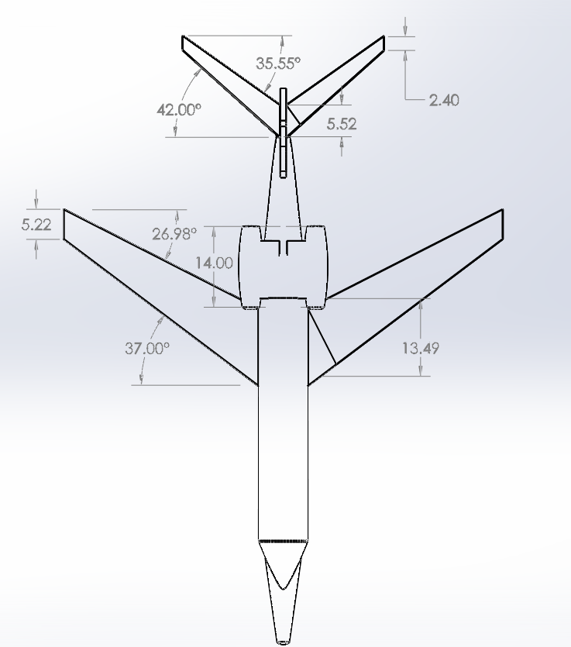

**Figure 1: Top View drawing of the aircraft. Note that the wing sweep angles match with the given parameters in the project handout. Horizontal stabilizer dimensions including chord lengths and sweep angles are based off of scaled ratios referenced from the Bombardier Global 5000.**

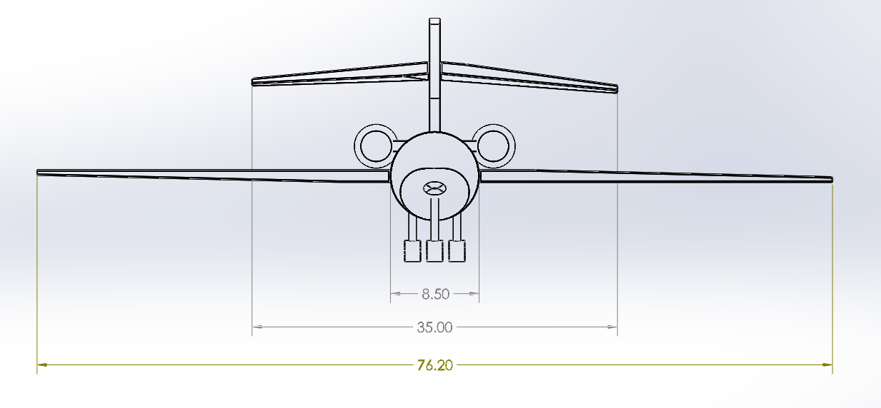

**Figure 2**: **Front View drawing of the aircraft. The horizontal tail span was an estimate based off of scaled ratios from the Bombardier Global 5000. All other dimensions are based off of our own design parameters.**

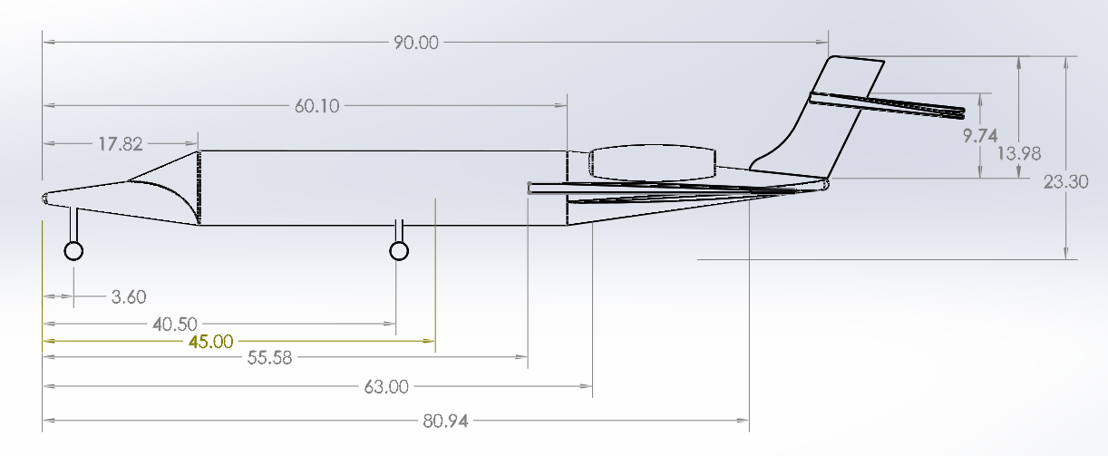

**Figure 3: Right View drawing of the aircraft. The vertical tail height and horizontal tail height are based off of scaled ratios referenced from the Bombardier Global 5000. All other parameters are based off of our own design parameters. This figure particularly highlights the center of gravity positioning locations laid out in Table 8 refer to Center of Gravity Placements of Exterior Components. Take note of the fuel tank placement center of gravities – where the underbelly fuel tank center of gravity is positioned 62.57 (rounded to 63 in Solidworks) ft from the tip of the nose, and the wing fuel tank center of gravity (on each side of the aircraft), is placed 60.1 ft back from the tip of the nose, which coincidentally lines up with the very start of the tail empennage structure.**

After the exterior design layout was complete, we moved to designing the interior of the cabin, calculating specific seating arrangements by again using the same MATLAB code that was used to compute the four different centers of gravity of the aircraft as well as the center of gravity locations of the exterior components. We made a design for the 12-seating arrangement and included a jumper seat for the stewardess. The results are summarized in the table below.

|  |  |  |
| --- | --- | --- |
| **Parameter** | **Value** | **Units** |
| Weight of Luxury Passenger | 45.000 | lb |
| Weight of Jump Seat | 30.000 | lb |
| Weight of Pilot Seat | 40.000 | lb |
| Weight of Passenger + Luggage | 200.000 | lb |
| Number of Passengers in Section 1 | 4.000 | unitless |
| Number of Passengers in Section 2 | 4.000 | unitless |
| Number of Passengers in Section 3 | 4.000 | unitless |
| Seating Section 1 Length | 10.000 | ft |
| Seating Section 2 Length | 10.000 | ft |
| Seating Section 3 Length | 10.000 | ft |
| Leading Edge Cockpit Placement | 4.500 | ft |
| Leading Edge Jump Seat Placement | 13.500 | ft |
| Leading Edge Placement of Seating Section 1 | 21.600 | ft |
| Leading Edge Placement of Seating Section 2 | 32.400 | ft |
| Leading Edge Placement of Seating Section 3 | 42.750 | ft |

**Table 10: Interior Design Specifications.**

When designing the interior of our aircraft, we made sure to consider not only the performance aspects, but also the ergonomic aspects. We wanted to ensure that we provided a high level of comfort and luxury to ensure that our design is highly competitive with existing aircraft. The forward most section of the cabin provides a standard lavatory, accommodations for a steward(ess) and a deluxe, full-service galley that allows for extremely high quality in-flight service. The forward lavatory also allows passengers to use the restroom without disturbing other passengers in the aft section. The first seating section features 2 sets of 2 seats which face a central table with a built-in tablet-based entertainment console. The forward 2 most chairs also have the ability to rotate 180 degrees and face forward where there are additional desks featuring their own individual entertainment consoles. This gives passengers the flexibility to socialize or engage in meetings as well as to simply relax in solitude. Section 2 is the most socially oriented area of the cabin with a full-service bar and 4 seats arranged around a central table. The bar stools enable passengers from other areas of the cabin to come and comfortably socialize as well. Seating section 3 offers the most opportunities for privacy and relaxation. The 3-seat couch maximizes the number of passengers that our aircraft can carry, but it also transforms into bed to allow passengers to sleep comfortably during their trip. A fold-down Murphy bed adds the capability for yet another passenger to enjoy a peaceful slumber. An additional single passenger seat and desk in section 3 can act as a study in the sky for passengers who prefer to be productive at all times. The final key feature in section 3 is the aft lavatory which includes a shower for passengers to refresh and reinvigorate themselves while traveling so that they land ready to hit the ground running. The shape of the beds ensures that this lavatory can be accessed at all times, even if both beds are being utilized and the bar stools give seating to passengers who may have been displaced by the deployment of the beds. Using these interior design parameters, we made our cabin layout as showcased in Figure 3 below.

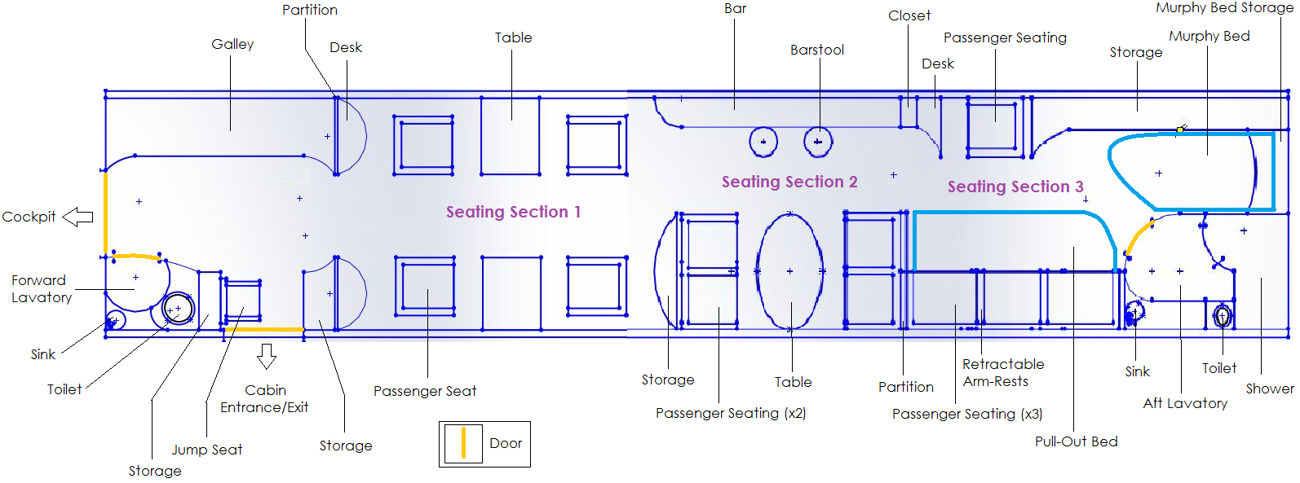

**Figure 4: The interior design of the cabin. Seating Section 1, 2, and 3 are clearly marked. There is a jump seat for the stewardess placed in the front of the cabin. Forward and rearward lavatories are included as well as a luxury suite in the back of the cabin featuring a bed and shower. A bartop and stools are included in Seating Section 2, and a storage compartment is placed in the back in Seating Section 3. The added on lavish components were designed to cater to the primary market of the aircraft which is VIPs, Movie Moguls, and rich, traveling businessmen and women.**

# Stability and Control

## Introduction

This section will outline the theory, assumptions and design for the stability and control of the Bolt Air B5 Condor Aircraft. This preliminary design document will only contain will only contain information related the inherit stability and control related to pitch, excluding roll and yaw.

To begin, the primary variables that factor into an aircraft’s ability to fly with pitch stability are the horizontal lifting surfaces, wing, tail and canard, and the the moments contributed by the fuselage and engine nacelles, due to their high weight.



**Figure 5: Force diagram for stability and control calculations. Referenced from Appendix C of the 154 Design Documentation.**

## Moment Coefficient and $C_{M_{alpha}}$ Calculations

The initial value we are most concerned with is $C_{M_{α}}.$ This is the Derivative of the Moment Coefficient about the center of gravity with respect to angle of attack. This value needs to be evaluated as a negative to make sure that the Moment Coefficient has a negative, and acts as a stable “gravity well”. A moment coefficient with a positive slope would tell us that with deflections in alpha, we would still a corresponding increase in $C_{M}$, which would cause the vehicle to continue to pitch out of stability.



**Figure 6: Plots of $M_{CG} vs. α$ to visualize stability trends. $M_{CG}$ must have a negative slope in order for the aircraft to be inherently stable. Otherwise, the vehicle will need to incorporate high reliability automatic control systems to maintain constant pitch during flight, which is not a very desirable characteristic.**

In our calculations for $M_{CG}, C_{M}$ and, we make a few assumptions for the preliminary design. The moments about the Aerodynamic centers of both the wing and the tail are zero due to the symmetrical wing chosen, Angle of attack vector values are assumed using the small angle approximation to linearize all equations, and moment from drag terms are assumed negligible. With all these assumptions, we end up with the following reduced moment equation.

*Original Moment Equation*



*Finalized Moment Equation*

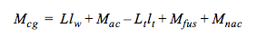

We then non-Dimensionalize this equation, and take the derivative with respect to alpha to determine.

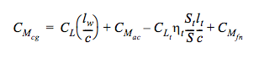

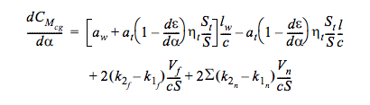

## Procedure and Trim Calculations

The Design method from here involves cross examinations between the four different required loading conditions, Center of Gravity Calculations, Subsonic and supersonic cruise to verify that as we change speed, weight, and altitude, we are able to maintain $C_{M_{α}}$ stability and trim the aircraft within reasonable tail angle of attack. This was done be creating a master excel spreadsheet which would automatically update all values listed above when running simulations for different placements of wing, tail, fuselage and engines to verify that we could find bounds with which all elements are satisfied.

|  |  |  |  |
| --- | --- | --- | --- |
| **Parameter** | **Value** | **Units** | ***Equation(s) Used*** |
| Tail Volume Ratio | 1.000 | ** | *Estimate from Average Values* |
| Tail Surface Area | 256.050 | ft^2 | *S_t = S_w*MAC/l_t* |
| Moment Coefficient about AC | 0.000 | ** | *0 due to symmetric wing* |
| Correction Coefficient (Tau) | 0.000 | ** | *Assumed 0 for preliary design* |
| DownWash Angle | 0.018 | ** | *epsilon = 2*C_L/(pi*AR)*(1+tau)* |

**Table 11: Constant Stability Values, indepent of Angle of Attack and $C_{L}$.**

|  |  |  |  |
| --- | --- | --- | --- |
| **Parameter** | **Value** | **Units** | ***Equation(s) Used*** |
| Mach Speed | 0.9000 | ** | *Input* |
| Lift Coefficient | 0.5000 | ** | *Provided in Appendix A* |
| Lift Coefficient of Tail | 0.1130 | ** | *Provided in Appendix A* |
| Angle of Attack | 0.0684 | Rad | *Provided in Appendix A* |
| Angle of Atttack Tail | 0.0155 | Rad | *alpha_t = CL_t_trim/A_t* |
| Lift Curve Slope for Wing | 7.3081 | 1/Rad | *a_w = C_L/alpha* |
| Lift Curve Slope for Tail | 7.3081 | 1/Rad | *a_t = C_Lt/alpha_t* |
| Derivative of Epsilon with alpha | 0.3747 | 1/rad | *dev_eps = epsilon/alpha* |
| Moment of Fuselage | 133995.2219 | ft-lb | *M_f = 2*q*(k2_f-k1_f)*Vol_f*alpha_w;* |
| Moment of Nacelle | 83825.2718 | ft-lb | *M_n = 2*q*(k2_n-k1_n)*Vol_n*alpha_w;* |

**Table13: Values for subsonic Cruise Stability at C_L = 0.5 and Mach = 0.9.**

|  |  |  |
| --- | --- | --- |
| **Parameter** | **Value** | **Units** |
| Moment Coefficients for C_L = 0.3 @ Initial Estimates | 0.0000 | ** | |
| Moment Coefficients for C_L = 0.4 @ Initial Estimates | 0.0000 | ** |
| Moment Coefficients for C_L = 0.5 @ Initial Estimates | 0.0000 | ** |
| Derivate of C_M_cg with alpha for C_L = 0.3 @ Initial Est. | -1.0516 | 1/Rad |
| Derivate of C_M_cg with alpha for C_L = 0.4 @ Initial Est. | -2.1762 | 1/Rad |
| Derivate of C_M_cg with alpha for C_L = 0.4 @ Initial Est. | -2.8575 | 1/Rad |

**Table 14: Subsonic Stability Values for $C_{L}$ = 0.3,0.4 and 0,5 at Mach 0.9. All $C_{M_{α}}$ values are negative and Moment Coefficients are zeroed out for trim.**

|  |  |  |  |
| --- | --- | --- | --- |
| **Parameter** | **Value** | **Units** | ***Equation(s) Used*** |
| Mach Speed | 1.8000 | ** | *\*\** |
| Lift Coefficient | 0.1154 | ** | *Taken from Appendix B Data.* |
| Lift Coefficient of Tail | 0.0646 | ** | *\*\** |
| Angle of Attack | 0.0426 | Rad | *\*\** |
| Angle of Atttack Tail | 0.0238 | Rad | *alpha_t = CL_t_trim/A_t* |
| Lift Curve Slope for Wing | 2.7098 | 1/Rad | *a_w = C_L/alpha* |
| Lift Curve Slope for Tail | 2.7098 | 1/Rad | *a_t = C_Lt/alpha_t* |
| Derivative of Epsilon with alpha | 0.4152 | 1/rad | *dev_eps = epsilon/alpha* |
| Moment of Fuselage | 83405.1891 | ft-lb | *M_f = 2*q*(k2_f-k1_f)*Vol_f*alpha_w;* |
| Moment of Nacelle | 52176.9549 | ft-lb | *M_n = 2*q*(k2_n-k1_n)*Vol_n*alpha_w;* |

**Table 15: Values for supersonic Cruise Stability at C_L = 0.1154 and Mach = 1.8.**

|  |  |  |
| --- | --- | --- |
| **Parameter** | **Value** | **Units** |
| Moment Coefficients for C_L = 0.3 @ Initial Estimates | 0.0000 | ** |
| Moment Coefficients for C_L = 0.4 @ Initial Estimates | 0.0000 | ** |
| Moment Coefficients for C_L = 0.5 @ Initial Estimates | 0.0000 | ** |
| Derivate of C_M_cg at M = 1.6 | -0.4070 | 1/Rad |
| Derivate of C_M_cg at M = 1.7 | -0.2220 | 1/Rad |
| Derivate of C_M_cg at M = 1.8 | -0.0623 | 1/Rad |

**Table 16: Supersonic Stability Values for Mach 1.8 flight. All $C_{M_{α}}$ values are negative and Moment Coefficients are zeroed out for trim.**

## Conclusions

Through multiple iterative process, design adjustments, and useful analysis using excel and visual basic, a configuration was found that would meet all requirements for CG placement, Percent Mean Aerodynamic Chord for the position of the CG, Moment Coefficient with respect to alpha, and Trim Conditions to meet the specifics of the design. Detailed excel document with all information and calculations can be found here.

<https://drive.google.com/open?id=0B2wg3fGpp_1adEtQVkhxN1JLTE0>

## Future Work and Improvements

Through the design process for stability and control, one major did occur and will need to be revisited and recalculated for all cases. The only conditions not met for trim was the required thrust to equal drag at supersonic cruise speeds and altitudes. The initial design utilized 2 Bruin Jet 220 engines. These two engines are sufficient for all subsonic cruise conditions, which allow for full trim and stability of the aircraft at subsonic speeds. In order to achieve the required thrust at Mach 1,6 to Mach 1,8 though, a third engine will be added.

This will greatly affect the placement of the Center of Gravity of the aircraft, and thus will have a very large impact on the stability and trim calculations. Initial estimates for corrections necessary are shown below.

|  |  |  |
| --- | --- | --- |
| **Parameter** | **Value** | **Units** |
| Moment Coefficients for Mach 1.6 | 0.0704 | ** |
| Moment Coefficients for Mach 1.7 | 0.0632 | ** |
| Moment Coefficients for Mach 1.7 | 0.0569 | ** |
| Derivate of C_M_cg at M = 1.6 | 0.6452 | 1/Rad |
| Derivate of C_M_cg at M = 1.7 | 0.7377 | 1/Rad |
| Derivate of C_M_cg at M = 1.8 | 0.8310 | 1/Rad |

**Table 17: Future Work Values that will need to be corrected during secondary design steps**.

As shown, adding a third engine will push back the cg significantly, and add much more weight to the rear of the vehicle. These values will need to be simulated once again with a third engine to verify a configuration that is trimmable for all updated scenarios.

# Subsonic Aerodynamics

## Drag Calculations

Working on aerodynamic calculation for subsonic aircraft when it is at the cruising speeds (M = 0.90, 0.92, 0.95) is required to break apart into smaller components of the aircraft, such as: fuselage, wing, tail, and nacelles; then, add them together to get the total drag and lift to the whole airplane. After that, we can look at the values of the total drag and lift to compare and predict whether the thrust and carrying weight is satisfied with the final results we obtain.

The total drag coefficient is the sum of parasite drag and induced drag. However, estimation of parasite drag is difficult because we need to calculate different skin friction drags of fuselage, wing, tail, and nacelles. Also, the parasite drag includes the additional miscellaneous drag term ($C_{D_{Misc}})$ and leakage-protuberance drag ($C_{D_{L\&P}})$. Therefore, it can be estimated by the formula:

$$C_{D_{P}}=\sum_{i=1}^{\# comp}{\frac{K_{i}Q_{i}C_{f_{i}}S_{{wet}_{i}}}{S_{ref}}}+C_{D_{Misc}}+C_{D_{L\&P}}$$

For the mid-placement wing transport jet, the addition miscellaneous drag term can be estimated as 1.5% of the parasite drag[1]; and the leakage-protuberance drag is about 5% of the parasite drag[2]. Thus, the formula can be derived into:

$$C_{D_{P}}=\sum_{i=1}^{\# comp}{\frac{K_{i}Q_{i}C_{f_{i}}S_{{wet}_{i}}}{S_{ref}}}+{0.015C}_{p}+0.05C_{D_{p}}$$

Thus, we have:

$$C_{D_{P}}=\sum_{i=1}^{\# comp}{\frac{K_{i}Q_{i}C_{f_{i}}S_{{wet}_{i}}}{S_{ref}×(1-0.065)}}$$

The wetted area of the wing is:

$$S_{{wet}_{wing}}=2.0 (1+0.2×\frac{t}{c})×S_{exposed}$$

Wetted Area of the fuselage is from the nose cone of the aircraft by the formula:

$$S_{{wet}_{nose}}=0.75×π×D×L_{nose}$$

And the wetted Area of the nacelles is

$$S_{{wet}_{nacelle}}=0.72×π×D×L_{nacelle}$$

While D can be get from the width (W) and the height (H) of the fuselage[3]:

|  |  |  |
| --- | --- | --- |
| Parameter | Variable | Value |
| Fuselage (const Diameter) | S_wetf = | 1126.088 |
| Nose Section | S_wetfn = | 574.874 |
| Tail Section | S_wetft = | 359.096 |
| Engine Cowling | S_wete = | 117.592 |
| Tail Surfaces | S_wett = | 173.599 |
| Frontal Area Fuselage (max) | S_frtf= | 13.352 |
| Frontal Area Engine Cowling | S_frte = | 6.681338543 |

**Table 18: Frontal and Wetted Areas of Aircraft**

Q is the interference factor and can be estimated by the table below:

|  |  |
| --- | --- |
| Interference Factor of Wing | 1 |
| Interference Factor of Tail | 1 |
| Interference Factor of Fuselage | 1 |
| Interference Factor of Nacelle | 1.25 |

**Table 19: Interference Factor of Different Components [Source: The Civil Engineering Handbook]**

The form factor of the wing and tail is predicted by the formula, where x/c is 0.5 by Raymer estimation (pg. 280); t/c is 0.06 from the NACA 64A006 maximum thickness; and Λm is geometrically estimated 33 degree at 40% of the wing’s chord length:

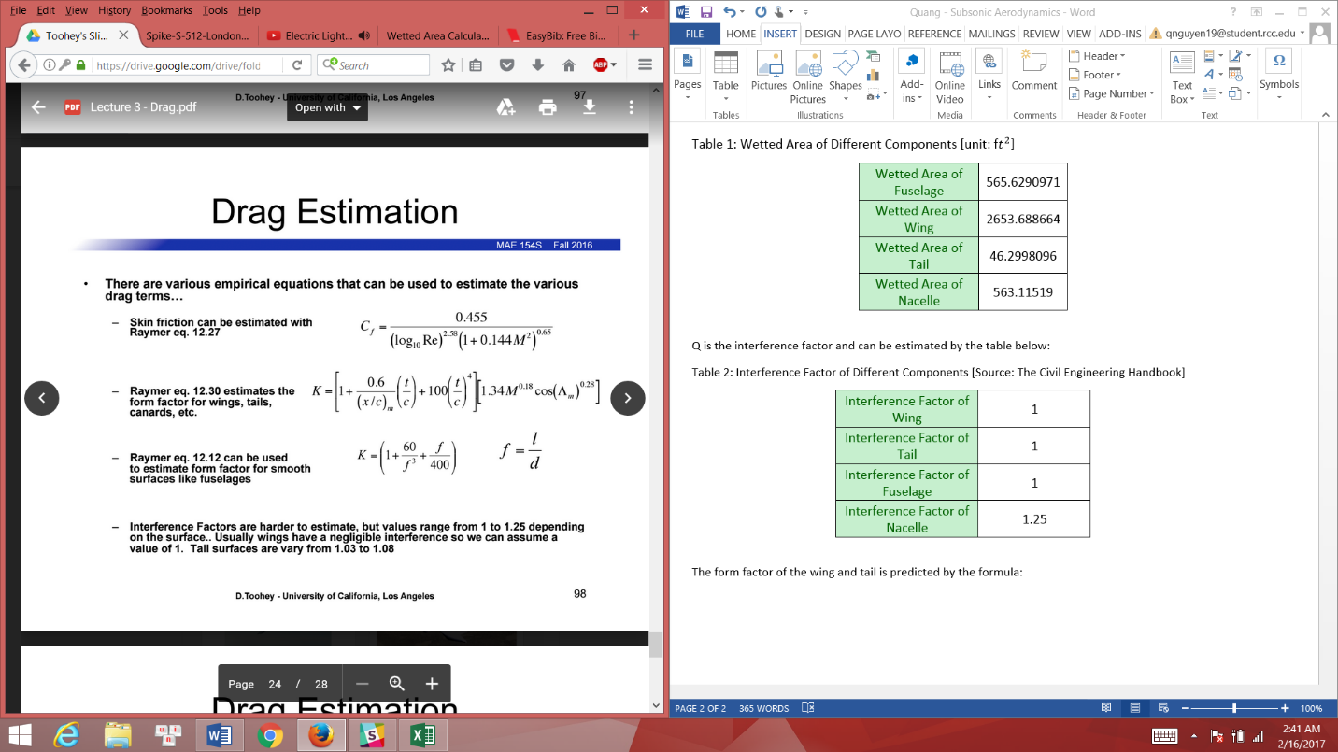

And form factor for the fuselage and nacelles are, where the fineness ratio for fuselage is 5 and for nacelles is 7:

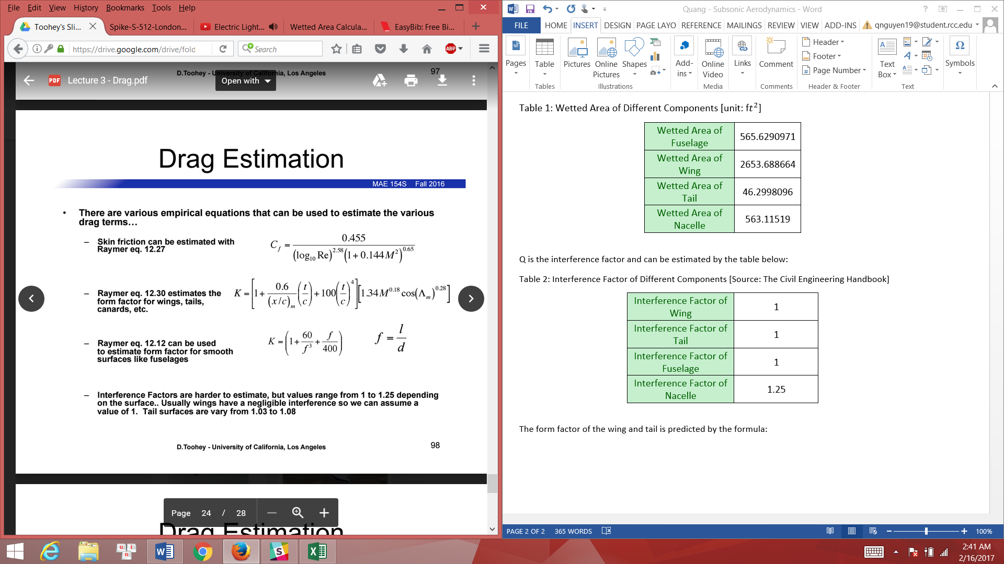

|  |  |
| --- | --- |
| Component Factor of Fuselage | 1.4925 |
| Component Factor of Wing | 1.343363529 |
| Component Factor of Tail | 1.477699882 |
| Component Factor of Nacelle | 1.05 |

**Table 19: Form Factor of Different Components**

Finally, Raymer estimates the skin friction coefficient of various altitude having different Reynolds Number by:

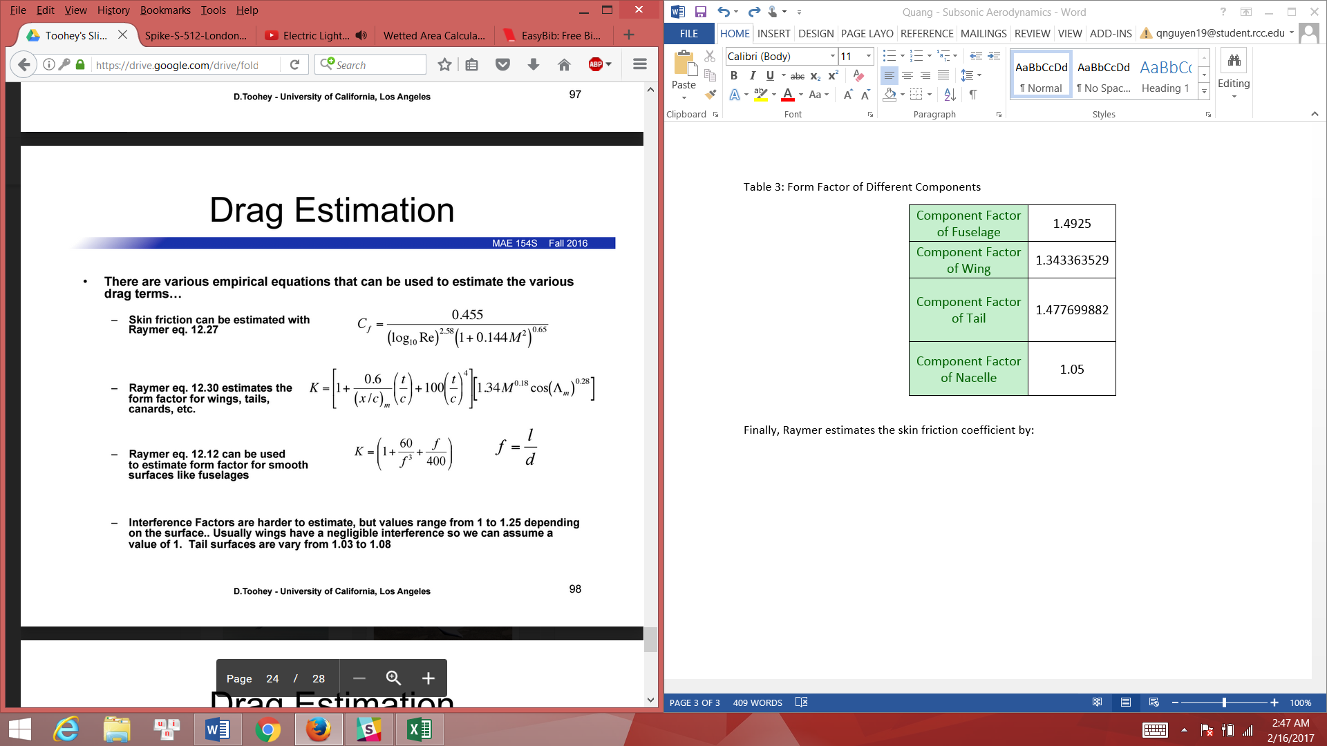

|  |  |  |  |  |  |  |  |  |  |  |
| --- | --- | --- | --- | --- | --- | --- | --- | --- | --- | --- |
| Calculation of Parasite Drag when M = 0.9 | | | | | | | | | | |
| Altitude [ft] | Density of Air | Reynolds Number for Fuselage | Reynolds Number for Wing | Reynolds Number for Tail | Reynolds Number for Nacelle | Skin Friction Coefficient of Fuselage | Skin Friction Coefficient of Wing | Skin Friction Coefficient of Tail | Skin Friction Coefficient of Nacelle | Parasite Drag  Coefficient |
| 41000 | 0.0005598 | 171814668.2 | 21314300.96 | 2815365.368 | 20772683.25 | 0.001838432 | 0.002483721 | 0.0034537 | 0.002493521 | 0.017792881 |
| 42000 | 0.0005336 | 163773324.4 | 20316739.89 | 2683599.429 | 19800471.2 | 0.001850476 | 0.002502015 | 0.003482627 | 0.002511917 | 0.017923511 |
| 43000 | 0.0005087 | 156130978.4 | 19368676.13 | 2558371.495 | 18876498.69 | 0.001862594 | 0.002520442 | 0.003511803 | 0.002530444 | 0.018055077 |
| 44000 | 0.0004849 | 148826246.2 | 18462494.7 | 2438675.718 | 17993344.24 | 0.001874854 | 0.002539107 | 0.003541398 | 0.002549212 | 0.018188346 |
| 45000 | 0.0004623 | 141889819.8 | 17602003.1 | 2325015.023 | 17154718.59 | 0.001887178 | 0.00255789 | 0.003571223 | 0.0025681 | 0.018322457 |
| 46000 | 0.0004407 | 135260314.9 | 16779586.34 | 2216383.562 | 16353200.26 | 0.001899647 | 0.002576915 | 0.003601475 | 0.00258723 | 0.018458292 |
| 47000 | 0.0004201 | 128937731.6 | 15995244.43 | 2112781.335 | 15588789.27 | 0.001912236 | 0.002596146 | 0.003632097 | 0.002606568 | 0.018595593 |
| 48000 | 0.0004005 | 122922069.7 | 15248977.37 | 2014208.342 | 14861485.6 | 0.001924917 | 0.002615539 | 0.003663021 | 0.002626069 | 0.018734048 |
| 49000 | 0.0003817 | 117151945.1 | 14533170.2 | 1919658.737 | 14163867.8 | 0.001937795 | 0.002635257 | 0.00369451 | 0.002645898 | 0.018874823 |

**Table 20: Skin Friction Coefficient by Different Components and Parasite Drag in Various Altitudes at Mach = 0.9.**

The induced drag includes wing and tail sections because both can produce lift for the aircraft, so the formula will become:

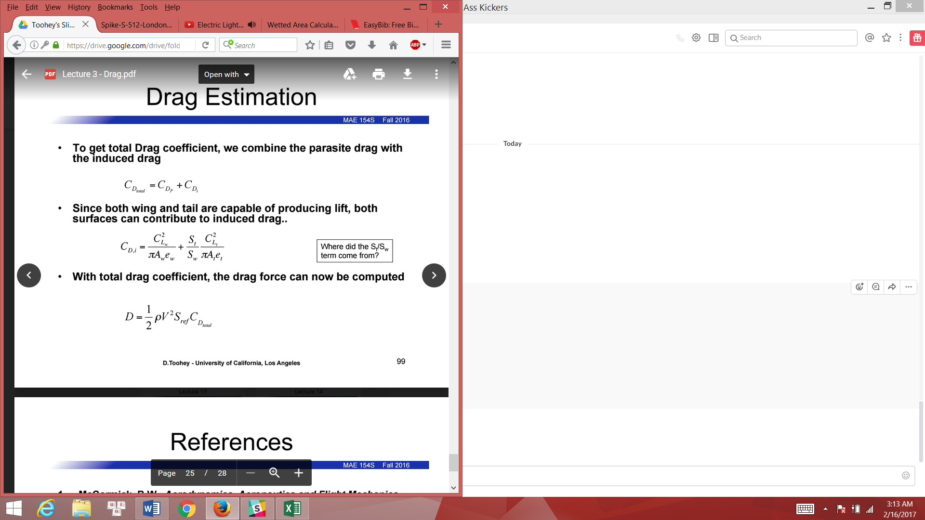

|  |  |  |
| --- | --- | --- |
| Calculation of Induced Drag when CL = 0.3 | | |
| Mach number | Lift Coefficient | Induced Drag Coefficient |
| 0.9 | 0.29995 | 0.004046102 |
| 0.92 | 0.29992 | 0.004045293 |
| 0.95 | 0.3 | 0.004047451 |

**Table 21: The Induced Drag by Different Lift Coefficients Varied by Various Mach Numbers**

At this point, we have all the necessary values to calculate the total aerodynamic lift and drag.

For the total drag coefficient, we combine the parasite drag coefficient and induced drag coefficient. Then multiply by the dynamic pressure of air to get the total drag. In addition, the lift is the product of the dynamic pressure of air and lift coefficient.

|  |  |  |  |  |  |  |
| --- | --- | --- | --- | --- | --- | --- |
| When CL = 0.3, M = 0.9 | | | | | | |
| Altitude [ft] | Density of Air | Parasite Drag | Total Drag Coefficient | Air Parameter | **Total Drag** | **Total Lift** |
| 41000 | 0.0005598 | 0.017792881 | 0.021838983 | 376211.8087 | **8216.083149** | **112844.732** |
| 42000 | 0.0005336 | 0.017923511 | 0.021969613 | 358604.1821 | **7878.395186** | **107563.3244** |
| 43000 | 0.0005087 | 0.018055077 | 0.022101179 | 341870.2163 | **7555.734873** | **102543.9714** |
| 44000 | 0.0004849 | 0.018188346 | 0.022234448 | 325875.5021 | **7245.661865** | **97746.35685** |
| 45000 | 0.0004623 | 0.018322457 | 0.022368559 | 310687.244 | **6949.625994** | **93190.63883** |
| 46000 | 0.0004407 | 0.018458292 | 0.022504394 | 296171.0327 | **6665.149568** | **88836.50126** |
| 47000 | 0.0004201 | 0.018595593 | 0.022641695 | 282326.8683 | **6392.358923** | **84683.94414** |
| 48000 | 0.0004005 | 0.018734048 | 0.02278015 | 269154.7506 | **6131.385725** | **80732.96745** |
| 49000 | 0.0003817 | 0.018874823 | 0.022920925 | 256520.2704 | **5879.681838** | **76943.25512** |

**Table 22: Total Drag and Lift for CL = 0.3 and M = 0.9**

## Conclusion

In conclusion, from the values of the total drag and lift, we have enough thrust and lift for the required carrying weight. However, in the future work, we can increase the nose cone to get smoother skin surface to reduce drag, add one more engine to have more thrust for higher speed at lower altitude, and invest variable wing sweep angle to achieve sufficient lift force in different purposes, such as: climbing, increasing acceleration, and fuel efficiency.

# Supersonic Aerodynamics

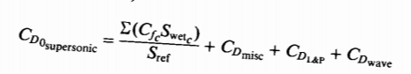 The calculations for the supersonic parasite drag will be achieved through a component build-up process similar to how the subsonic drag was calculated. The components of the parasite drag will be the skin friction drag, the wave drag, drag due to leaks and protuberances, and miscellaneous drag. The equation taken from Raymer is shown below.

Before the calculations of the parasite drag coefficients, it is necessary to calculate the frontal and wetted areas of certain components. The equations for the wetted area of the nose a tail empennage are as follows.

$$S_{\begin{aligned}wetted nose \\ \end{aligned}}=.75*πDL_{nose}$$

$$S_{\begin{aligned}wetted tail \\ \end{aligned}}=.72*πDL_{nose}$$

The constant diameter section of the fuselage and the engine cowling are treated as a cylinder. The results of these calculations can again be referred to in table 18.

 Empirical graphs and equations can be used to calculate the drag due to leaks and protuberances, as well as miscellaneous drag.  The miscellaneous drag is taken to be 1.5% of the total drag and the drag due to leakage and protuberances is 5% of the Skin Friction Drag (Raymer). In supersonic flow, there are no interference effects, and from factors are also not present. Thus, the skin friction drag for a particular component will be the product the ratio of its wetted area to the reference area (wing area) and the skin friction coefficient.  The skin friction coefficient can be evaluated by the two equations below.

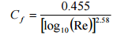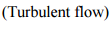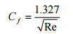

Since in the supersonic regime we will have nearly entirely turbulent flow we will be using the equation on the right. The skin friction values and their accompanying Reynolds number are in appendix A. The parasite drag coefficients for the air foils where taken from the NACA 64A0010 drag polar provided in the week 6 lecture slide, the zero lift drag coefficient was determined to be .004. Lastly we will need to account for the wave drag’s contribution to the parasite drag. Wave drag is directly dependent on the volume distribution of the aircraft. The minimum drag will occur at the volume distribution of the Sears-Hackley body (Shevel). This distribution will have a wave drag given by

$$C_{Dw}=\frac{9.87}{{(l/d}^{2})}$$

Assuming our fuselage has a similar volume distribution as the Sears-Hackley body we can estimate the wave drag coefficient with (Shevel)

$$C_{Dw}=\frac{10.67}{{(l/d}^{2})}$$

Once each component’s drag contribution is calculated they can be summed to yield the total parasite drag. These values are in appendix 3. The total Parasite drag is shown below

|  |  |  |  |
| --- | --- | --- | --- |
| **Altitude** | ***Total Aircraft Parasite Drag*** | ***Total Aircraft Parasite Drag*** | ***Total Aircraft Parasite Drag*** |
| ***(lbs) Mach 1.6*** | ***(lbs)Mach 1.7*** | ***(lbs)Mach 1.8*** |
| 41000ft | *13292.27819* | *13291.10981* | *13290.02011* |
| 42000ft | *12671.05669* | *12676.73746* | *12675.6381* |
| 43000ft | *12080.62525* | *12092.90038* | *12091.79129* |
| 44000ft | *11516.24443* | *11534.90706* | *11533.7881* |
| 45000ft | *10980.28851* | *11005.09986* | *11003.97095* |
| 46000ft | *10468.01734* | *10498.78803* | *10497.64904* |
| 47000ft | *9979.433412* | *10015.96974* | *10014.82054* |
| 48000ft | *9514.539334* | *9556.642763* | *9555.483261* |
| 49000ft | *9068.593563* | *9116.118309* | *9114.94832* |

**Table 23: Parasite drag values for aircraft at different supersonic Mach Numbers.**

Wind tunnel data was used to compute the induced drag, and the wave drag related to lift. This data was provided by Professor Bendiksen in appendix B of the design project. First the lift coefficient needed to achieve trimmed flight was calculated by setting lift then that value was used to determine what the angle of attack would be. Width the angle of attack now calculated the lift to drag (induced and wave) ratio and the drag (induced and wave) coefficient can be pulled from the table. Since our design lift coefficient was not a value on the table all other values had to be obtained by interpolation.  The computed drags are shown below.

|  |  |  |  |
| --- | --- | --- | --- |
| **Altitude** | **Drag Mach 1.6** | **Drag Mach 1.7** | **Drag Mach1.8** |
| 41000ft | 20871.7758 | 21038.346 | 21041.80247 |
| 42000ft | 19894.92472 | 20053.69901 | 20056.99371 |
| 43000ft | 18966.54448 | 19117.9097 | 19121.05066 |
| 44000ft | 18079.17861 | 18223.46208 | 18226.45609 |
| 45000ft | 17236.55224 | 17374.11101 | 17376.96548 |
| 46000ft | 16431.21076 | 16562.34239 | 16565.06348 |
| 47000ft | 15663.15323 | 15788.15527 | 15790.74917 |
| 48000ft | 14932.37995 | 15051.54995 | 15054.02283 |
| 49000ft | 14231.43428 | 14345.01028 | 14347.36708 |

**Table 24: Induced and Wave Drag for aircraft at supersonic Mach Numbers.**

In order to find the total drag of the aircraft the parasite, induced, and wave drag previously calculated had to simply be added together. The result is shown in the table below.

**Table 25: Total Drag for Aircraft at supersonic cruise Mach numbers.**

|  |  |  |  |
| --- | --- | --- | --- |
| **Altitude** | **Total Drag Mach 1.6** | **Total Drag Mach 1.7** | **Total Drag Mach1.8** |
| 41000ft | 34164.05399 | 34329.45581 | 34331.82258 |
| 42000ft | 32565.98141 | 32730.43647 | 32732.63182 |
| 43000ft | 31047.16972 | 31210.81008 | 31212.84195 |
| 44000ft | 29595.42304 | 29758.36914 | 29760.24419 |
| 45000ft | 28216.84075 | 28379.21087 | 28380.93643 |
| 46000ft | 26899.2281 | 27061.13042 | 27062.71252 |
| 47000ft | 25642.58664 | 25804.12501 | 25805.56971 |
| 48000ft | 24446.91929 | 24608.19271 | 24609.50609 |
| 49000ft | 23300.02784 | 23461.12859 | 23462.3154 |

From these calculations, it is clear that our current aircraft has too much drag and it will restrict our ability to meet the design requirements. Moving forward the top priority is to reduce the drag. The largest contributor to the parasite drag is the is the wave drag in order to reduce this we seek to reduce the fineness ratio of our plane using

$$C_{Dw}=\frac{10.67}{{(l/d}^{2})}$$

Attempts at maintaining laminar flow for a large portion of airfoils can be made as well. Either through supersonic natural laminar flow like the Aerion As2 or boundary layer control techniques. This would provide lower parasite drag for our tail and wing surfaces.

The calculations for the drags associated with lift were all made with limited data from tables. With the use of a CFD code we will be able to greater manipulate our aerodynamic properties and wing geometries. Thus, allowing us to investigate potential changes to thickness and the possible incorporation of variable swept wings.

# Takeoff and Performance

## Takeoff

The first condition where Thrust requirements must be determined and met are for the period of time when the aircraft is still on the runway. This is necessary to determine that the aircraft has enough thrust at sea level to accelerate the vehicle to lift off speeds within standard runway distances. To calculate this, we will use the Hartman approximation. The Hartman approximation breaks the takeoff procedure into 4 sections, ground roll, rotation distance, transition distance and climb distance.



### Ground Roll

Ground roll distance is the time the aircraft spends with all landing gear in contact with the ground. This is calculated using the linear relationship between acceleration and velocity squared. The approximation is valid between zero velocity and the take off velocity. Takeoff velocity is calculated using average values accepted within the Aerospace community. We selected a $C_{L_{Max}}$ of 1.8, which gives us a $V_{T0}$ of 226.6 feet per second.

$$\frac{1}{a}=αV^{2}$$

$$V_{T0}= sqrt\left(2*\frac{MTOW}{S*C_{L_{Max}}*ρ_{sea level}}\right)$$

Using these relations, we can calculate an integral form for the ground roll distance.

$$s=\frac{1}{2}*\int_{0}^{V_{T0}}{\frac{1}{a}d\left(V^{2}\right)}$$

$$s_{g}=\frac{1}{2}*Mass*V_{T0}^{2}/T_{e}$$

T­e is the excess thrust and is the total Thrust during takeoff minus the total drag. Performing these calculations with a **two-engine configuration** obtain a ground of roll distance of 1450 ft.

## Rotation, Transition and Climb Distance

The rotation distance is simply the distance while the aircraft is rotating its front wheels forward to achieve the desired angle of attack for lift of. This distance is given by

$$s_{R}=V_{T0}*t_{R}$$

Where $t_{R}$ values are accepted at 3 seconds.

The transition distance is the time while the aircraft flies in a circular arc, and thus the horizontal distance is simply the radius of the circle the vehicle is flying at.

$$\frac{L}{W}=1.152$$

Equation: Given Lift to Weight Ratio for $C_{L}=0.8C_{L_{Max}}$

$$R=\frac{V_{TO}^{2}}{1.152*g }$$

$$s_{TR}=R*\frac{T-D}{W}$$

The Climb distance is simply the distance of the straight line the vehicle takes to get to height h, at the angle $γ_{CL}$.

$$s_{CL}=\frac{h-R*\left(1-\cos\left(γ_{CL}\right)\right)}{\tan\left(γ_{cl}\right)}$$

The total calculations were coded in Matlab, which can be found in appendix A, and run to give us a total runway length of 2599 ft. This is well within the acceptable bounds of the specific 6000-foot runway. Thus, the thrust requires for takeoff are met.

## Performance

The primary performance component we are interested in is that the aircraft will be able to meet the service ceiling specification for flight. This requires the aircraft to have a max thrust capable of acquiring a rate of Climb equal to about 100 ft for a given altitude. A rate of climb of 100 ft per minute is an industry standard accepted as the point at which the aircraft will not continue to climb anymore.

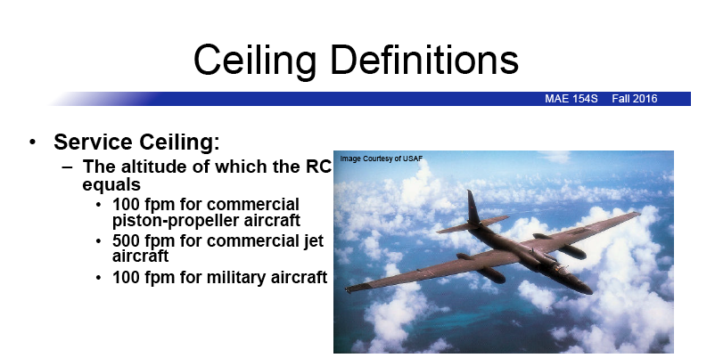

Image: Ceiling Definitions from Adjunct Professor Toohey, UCLA MAE 154S.

Using the excess power equation, along with the density of air at the prescribed max altitude, we can calculate the required thrust to achieve the service ceiling specification.

$$RC=\left(T_{AV}-T_{Req}\right)*\frac{V}{W}=sqrt\left(\frac{2W}{ρSC_{L}}\right)\left(\frac{T_{Av}}{W}-\frac{C_{D}}{C_{L}}\right)$$

$$T_{AV}=MTOW* \left(RC*sqrt\left(\frac{ρSC_{L}}{2W}\right)+\frac{C_{D}}{C_{L}}\right)$$

Results from these calculations at different altitudes are given in the following table.

|  |  |  |
| --- | --- | --- |
| Thrust Required at 51,000 feet | Thrust Available 2 Engines | Thrust Available 2 Engines |
| 13034 lb | 6520 lb | 9780 lb |
| Thrust Required at 51,000 feet | Thrust Available 2 Engines | Thrust Available 2 Engines |
| 13676 lb | 8282 lb | 12423 lb |
| Thrust Required at 51,000 feet | Thrust Available 2 Engines | Thrust Available 2 Engines |
| 14273 lb | 10522 lb | 15783 lb |

## Conclusions

As Shown by the table above, the current design for the aircraft does not meet the required service ceiling specification. There primary reasons for these issues is the large amount of drag our aircraft is currently facing. The two primary areas where the current design comes up short are the required thrust at top speeds, and required thrust at required service ceiling specs.

In order to solve this issue after the submission of this preliminary design, we are going to focus on adjusting key variables that affect drag, such as all frontal and wetted areas, the wing area and its effect on the lift and drag coefficient, and the engine design itself. The dimensions used to calculate the Ram Drag of the engines were based on estimates of the Douglas D-9 Engines. These values can be adjusted when in depth engine design and research is completed in order to maintain thrust to drag ratios for the engines.

# Conclusion

To this point the stability of our aircraft has been the primary focus. The condor is currently stable and is able to achieve trimmable flight at subsonic and supersonic regimes. The cabin layout provides comfortable and luxurious travel for up to twelve passengers and a stewardess. Our most prevalent shortcoming are our high drag values which currently exceed the capabilities of the available engines. Thus, restricting our service ceiling to approximately 41000 fee with 3 engines, a whole 10000 feet short of the design goal. Additionally, our current engines do not have enough thrust to allow us to reach trimmed flight at our supersonic cruise of mach 1.6-1.8. We are however capable of taking off with in 6000 feet and subsonic cruise of mach .8.  Next we will begin to greater reduce our drag at supersonic speeds through the use of an euler cfd code to allow manipulation of our airfoil geometry and associated aerodynamic properties. We also plan to implement the use of various techniques to reduce the skin friction drag and variable sweep wings to reduce wave drag. The resizing of the engine's core to create a lower bypass ratio can also be done. In the coming weeks with reductions in drag and increases in thrust the B-5 Condor will be able to meet all the design specifications

# Future Work

The most crucial areas of improvement for ensuring the future success of the B-5 Condor are minimizing drag and maximizing propulsive performance. In its current state, the aircraft is anemic and underpowered so several steps must be taken to boost the thrust as well as reduce drag forces that counteract thrust.

Firstly, we will utilize new methods taken from lecture and a high-level CFD code from our Professor to spark a detail analysis of potential alternate airfoils that could provide more favorable lift characteristics in our regimes of interest. We will also experiment with various wing geometry and will put special attention towards investigating the possible use of a variable-geometry wing. The ability to increase wing sweep at higher speed to reduce wave drag is very alluring, but must be tempered with the potential drawbacks of increased weight and complexity.

The data from the CFD code should also allow us to better optimize wing dimensions in order to minimize drag and will give us a more accurate model of our induced and wave drags. Armed with this additional information, we will look to further reduce drag through several other methods as well. For instance, parasitic wave drag is the largest contributor to parasite drag and can be reduced by increasing our fineness ratio. Additionally, we may look to employ boundary layer control techniques in order maintain lower Reynolds number flow around the aircraft, thus reducing the skin friction coefficient and eliminating drag. We will continue to look for as many more ways to reduce drag as possible during this stage.

Upon achieving a significant drag reduction, we will reassess the performance characteristics of our aircraft and the resulting propulsive requirements of our aircraft. At this stage, it is likely that we will still be facing a significant thrust deficiency and will need to add a third engine to our design. In concert with this measure, we will also perform a much more comprehensive analysis of engine characteristics involving for utilizing of engine performance data via Matlab coding. We will look for possible ways to optimize thrust and performance of the engine by tweaking parameters, just as bypass ratio. We will also look for ways to optimize fuel consumption to minimize the weight of fuel that we must carry which would also be helpful in improving aircraft performance. At the end of this process, we hope to have enough thrust to meet all desired design performance parameters and perhaps even have some excess thrust to allow for a safer, more maneuverable, and more operationally flexible aircraft.

After adding an engine, changing the wings, or performing any other of our many possible design revisions, we will want to revisit the stability analysis of our aircraft. We will perform a comprehensive evaluation of our stability characteristics and make any needed modifications to the size and/or placement of various components to ensure that the CG is properly placed and that the aircraft is stable under all loading conditions. We will seek to not just match our current levels of stability, but to exceed them. We want stability that is optimized so that we experience minimal trim drag penalties while trimming our aircraft which will also contribute towards overall less drag and a more effective use of propulsive power for the aircraft.

As outlined above, a comprehensive and iterative review and revision process will be carried out for the B-5 Condor to ensure that it meets desired performance parameters. Airfoils and wings will be aerodynamically optimized and the entire airframe will be assessed for opportunities to reduce drag. The propulsive power of the aircraft will be adjusted accordingly through the likely addition of a third engine and maximization of favorable powerplant characteristics. Stability will be preserved and improved to lesson trim drag. With hard work, dedication, and ingenuity, these are all highly attainable goals for our team here at Bolt Air.

# References

1. “Aircraft Design Project. Appendices A – C.” MAE 154A, Professor O. O. Bendiksen,

University of California at Los Angeles, Winter 2017. Class Handout.

1. Bendiksen, O.O. “MAE 154A – Chapter 1 Slides – Chapter 4 Slides.” PowerPoint Presentation. University of California at Los Angeles. Winter 2017. MAE 154A Lecture Series.
2. “BruinJet BJ205, 209, 220 Performance.” MAE 154A, Professor O. O. Bendiksen, University of California at Los Angeles, Winter 2017. Class Handout.
3. “Gas Turbine Engines.” MAE 154A, Professor O.O. Bendisken, University of California at Los Angeles, Winter 2017. Class Handout.
4. McCormick, B. W. Aerodynamics, Aeronautics, and Flight Mechanics. 2nd ed. N.p. : John Wiley &amp; Sons, n.d. Print.
5. Raymer, Daniel P. Aircraft Design: A Conceptual Approach. Reston, VA: American Institute of Aeronautics and Astronautics, 2012. Print.
6. Spearrin, R.M. “MAE 150P – Aircaft Propulsion Systems. Lectures 1 – 18.” PowerPoint Presentation. University of California at Los Angeles. Fall 2016. MAE C150P Lecture Series.
7. Toohey, D. “MAE 154S. Lectures 1 – 18.” PowerPoint Presentation. University of California at Los Angeles. Fall 2016. MAE 154S Lecture Series.
8. Torenbeek, Egbert. Synthese of Subsonic Airplane Design. N.p. : Nijhoff, 1982. Print.

# Appendix A

|  |  |  |  |  |  |  |  |  |  |  |
| --- | --- | --- | --- | --- | --- | --- | --- | --- | --- | --- |
| Calculation of Parasite Drag when M = 0.9 | | | | | | | | | | |
| Altitude [ft] | Density of Air | Reynolds Number for Fuselage | Reynolds Number for Wing | Reynolds Number for Tail | Reynolds Number for Nacelle | Skin Friction Coefficient of Fuselage | Skin Friction Coefficient of Wing | Skin Friction Coefficient of Tail | Skin Friction Coefficient of Nacelle | Parasite Drag  Coefficient |
| 41000 | 0.0005598 | 171814668.2 | 21314300.96 | 2815365.368 | 20772683.25 | 0.001838432 | 0.002483721 | 0.0034537 | 0.002493521 | 0.017792881 |
| 42000 | 0.0005336 | 163773324.4 | 20316739.89 | 2683599.429 | 19800471.2 | 0.001850476 | 0.002502015 | 0.003482627 | 0.002511917 | 0.017923511 |
| 43000 | 0.0005087 | 156130978.4 | 19368676.13 | 2558371.495 | 18876498.69 | 0.001862594 | 0.002520442 | 0.003511803 | 0.002530444 | 0.018055077 |
| 44000 | 0.0004849 | 148826246.2 | 18462494.7 | 2438675.718 | 17993344.24 | 0.001874854 | 0.002539107 | 0.003541398 | 0.002549212 | 0.018188346 |
| 45000 | 0.0004623 | 141889819.8 | 17602003.1 | 2325015.023 | 17154718.59 | 0.001887178 | 0.00255789 | 0.003571223 | 0.0025681 | 0.018322457 |
| 46000 | 0.0004407 | 135260314.9 | 16779586.34 | 2216383.562 | 16353200.26 | 0.001899647 | 0.002576915 | 0.003601475 | 0.00258723 | 0.018458292 |
| 47000 | 0.0004201 | 128937731.6 | 15995244.43 | 2112781.335 | 15588789.27 | 0.001912236 | 0.002596146 | 0.003632097 | 0.002606568 | 0.018595593 |
| 48000 | 0.0004005 | 122922069.7 | 15248977.37 | 2014208.342 | 14861485.6 | 0.001924917 | 0.002615539 | 0.003663021 | 0.002626069 | 0.018734048 |
| 49000 | 0.0003817 | 117151945.1 | 14533170.2 | 1919658.737 | 14163867.8 | 0.001937795 | 0.002635257 | 0.00369451 | 0.002645898 | 0.018874823 |
| Calculation of Parasite Drag when M = 0.92 | | | | | | | | | | |
| Altitude [ft] | Density of Air | Reynolds Number for Fuselage | Reynolds Number for Wing | Reynolds Number for Tail | Reynolds Number for Nacelle | Skin Friction Coefficient of Fuselage | Skin Friction Coefficient of Wing | Skin Friction Coefficient of Tail | Skin Friction Coefficient of Nacelle | Parasite Drag  Coefficient |
| 41000 | 0.0005598 | 175632772 | 21787952.09 | 2877929.043 | 21234298.43 | 0.001827374 | 0.00246787 | 0.00343009 | 0.002477596 | 0.017679526 |
| 42000 | 0.0005336 | 167412731.6 | 20768223 | 2743234.972 | 20240481.68 | 0.001839333 | 0.002486024 | 0.003458777 | 0.00249585 | 0.017809154 |
| 43000 | 0.0005087 | 159600555.7 | 19799091.16 | 2615224.195 | 19295976.44 | 0.001851363 | 0.002504309 | 0.00348771 | 0.002514235 | 0.017939709 |
| 44000 | 0.0004849 | 152133496.1 | 18872772.36 | 2492868.512 | 18393196.34 | 0.001863535 | 0.00252283 | 0.003517058 | 0.002532858 | 0.018071951 |
| 45000 | 0.0004623 | 145042926.9 | 17993158.72 | 2376682.023 | 17535934.55 | 0.001875771 | 0.002541468 | 0.003546633 | 0.002551599 | 0.018205028 |
| 46000 | 0.0004407 | 138266099.7 | 17152466.04 | 2265636.53 | 16716604.71 | 0.001888149 | 0.002560346 | 0.003576631 | 0.002570582 | 0.018339814 |
| 47000 | 0.0004201 | 131803014.5 | 16350694.31 | 2159732.031 | 15935206.81 | 0.001900647 | 0.002579428 | 0.003606996 | 0.00258977 | 0.018476052 |
| 48000 | 0.0004005 | 125653671.3 | 15587843.54 | 2058968.528 | 15191740.84 | 0.001913236 | 0.00259867 | 0.003637661 | 0.002609119 | 0.018613434 |
| 49000 | 0.0003817 | 119755321.7 | 14856129.54 | 1962317.82 | 14478620.42 | 0.001926021 | 0.002618235 | 0.003668884 | 0.002628793 | 0.018753115 |
| Calculation of Parasite Drag when M = 0.95 | | | | | | | | | | |
| Altitude [ft] | Density of Air | Reynolds Number for Fuselage | Reynolds Number for Wing | Reynolds Number for Tail | Reynolds Number for Nacelle | Skin Friction Coefficient of Fuselage | Skin Friction Coefficient of Wing | Skin Friction Coefficient of Tail | Skin Friction Coefficient of Nacelle | Parasite Drag  Coefficient |
| 41000 | 0.0005598 | 181359927.6 | 22498428.79 | 2971774.555 | 21926721.2 | 0.001810964 | 0.002444393 | 0.003395199 | 0.002454008 | 0.017511619 |
| 42000 | 0.0005336 | 172871842.4 | 21445447.67 | 2832688.286 | 20900497.38 | 0.001822794 | 0.00246234 | 0.003423532 | 0.002472053 | 0.017639771 |
| 43000 | 0.0005087 | 164804921.7 | 20444713.69 | 2700503.244 | 19925193.06 | 0.001834696 | 0.002480416 | 0.003452108 | 0.002490228 | 0.017768836 |
| 44000 | 0.0004849 | 157094371 | 19488188.85 | 2574157.702 | 18992974.48 | 0.001846739 | 0.002498725 | 0.003481093 | 0.002508638 | 0.017899568 |
| 45000 | 0.0004623 | 149772587.6 | 18579892.16 | 2454182.524 | 18107758.51 | 0.001858843 | 0.00251715 | 0.003510302 | 0.002527165 | 0.018031122 |
| 46000 | 0.0004407 | 142774776.9 | 17711785.58 | 2339515.982 | 17261711.39 | 0.001871089 | 0.002535811 | 0.003539928 | 0.002545929 | 0.018164362 |
| 47000 | 0.0004201 | 136100938.9 | 16883869.12 | 2230158.075 | 16454833.12 | 0.001883453 | 0.002554674 | 0.003569915 | 0.002564896 | 0.018299036 |
| 48000 | 0.0004005 | 129751073.6 | 16096142.78 | 2126108.806 | 15687123.69 | 0.001895906 | 0.002573694 | 0.003600197 | 0.002584023 | 0.018434837 |
| 49000 | 0.0003817 | 123660386.5 | 15340568.54 | 2026306.445 | 14950749.35 | 0.001908553 | 0.002593033 | 0.00363103 | 0.00260347 | 0.018572908 |

Table 6: Total Drag and Lift by Different Lift Coefficient with Various Mach Numbers.

|  |  |  |  |  |  |  |
| --- | --- | --- | --- | --- | --- | --- |
| When CL = 0.3, M = 0.9 | | | | | | |
| Altitude [ft] | Density of Air | Parasite Drag | Total Drag Coefficient | Air Parameter | **Total Drag** | **Total Lift** |
| 41000 | 0.0005598 | 0.017792881 | 0.021838983 | 376211.8087 | **8216.083149** | **112844.732** |
| 42000 | 0.0005336 | 0.017923511 | 0.021969613 | 358604.1821 | **7878.395186** | **107563.3244** |
| 43000 | 0.0005087 | 0.018055077 | 0.022101179 | 341870.2163 | **7555.734873** | **102543.9714** |
| 44000 | 0.0004849 | 0.018188346 | 0.022234448 | 325875.5021 | **7245.661865** | **97746.35685** |
| 45000 | 0.0004623 | 0.018322457 | 0.022368559 | 310687.244 | **6949.625994** | **93190.63883** |
| 46000 | 0.0004407 | 0.018458292 | 0.022504394 | 296171.0327 | **6665.149568** | **88836.50126** |
| 47000 | 0.0004201 | 0.018595593 | 0.022641695 | 282326.8683 | **6392.358923** | **84683.94414** |
| 48000 | 0.0004005 | 0.018734048 | 0.02278015 | 269154.7506 | **6131.385725** | **80732.96745** |
| 49000 | 0.0003817 | 0.018874823 | 0.022920925 | 256520.2704 | **5879.681838** | **76943.25512** |
| When CL = 0.4, M = 0.9 | | | | | | |
| Altitude [ft] | Density of Air | Parasite Drag | Total Drag Coefficient | Air Parameter | **Total Drag** | **Total Lift** |
| 41000 | 0.0005598 | 0.017792881 | 0.024989069 | 376211.8087 | **9401.182753** | **150492.2477** |
| 42000 | 0.0005336 | 0.017923511 | 0.025119699 | 358604.1821 | **9008.02925** | **143448.8449** |
| 43000 | 0.0005087 | 0.018055077 | 0.025251265 | 341870.2163 | **8632.655503** | **136754.9239** |
| 44000 | 0.0004849 | 0.018188346 | 0.025384534 | 325875.5021 | **8272.197768** | **130356.7183** |
| 45000 | 0.0004623 | 0.018322457 | 0.025518645 | 310687.244 | **7928.317575** | **124281.1113** |
| 46000 | 0.0004407 | 0.018458292 | 0.02565448 | 296171.0327 | **7598.113833** | **118474.3365** |
| 47000 | 0.0004201 | 0.018595593 | 0.025791781 | 282326.8683 | **7281.712878** | **112936.3938** |
| 48000 | 0.0004005 | 0.018734048 | 0.025930237 | 269154.7506 | **6979.246374** | **107667.2833** |
| 49000 | 0.0003817 | 0.018874823 | 0.026071011 | 256520.2704 | **6687.742786** | **102613.2386** |
| When CL = 0.5, M = 0.9 | | | | | | |
| Altitude [ft] | Density of Air | Parasite Drag | Total Drag Coefficient | Air Parameter | **Total Drag** | **Total Lift** |
| 41000 | 0.0005598 | 0.017792881 | 0.029039398 | 376211.8087 | **10924.96457** | **188136.0013** |
| 42000 | 0.0005336 | 0.017923511 | 0.029170029 | 358604.1821 | **10460.49438** | **179330.7794** |
| 43000 | 0.0005087 | 0.018055077 | 0.029301595 | 341870.2163 | **10017.34255** | **170962.4578** |
| 44000 | 0.0004849 | 0.018188346 | 0.029434864 | 325875.5021 | **9592.100953** | **162963.8211** |
| 45000 | 0.0004623 | 0.018322457 | 0.029568975 | 310687.244 | **9186.703309** | **155368.477** |
| 46000 | 0.0004407 | 0.018458292 | 0.02970481 | 296171.0327 | **8797.704127** | **148109.21** |
| 47000 | 0.0004201 | 0.018595593 | 0.029842111 | 282326.8683 | **8425.229743** | **141186.0203** |
| 48000 | 0.0004005 | 0.018734048 | 0.029980566 | 269154.7506 | **8069.411822** | **134598.9077** |
| 49000 | 0.0003817 | 0.018874823 | 0.030121341 | 256520.2704 | **7726.734425** | **128280.6568** |
| When CL = 0.3, M = 0.92 | | | | | | |
| Altitude [ft] | Density of Air | Parasite Drag | Total Drag Coefficient | Air Parameter | **Total Drag** | **Total Lift** |
| 41000 | 0.0005598 | 0.017679526 | 0.021724818 | 393118.1172 | **8540.419661** | **117903.9857** |
| 42000 | 0.0005336 | 0.017809154 | 0.021854447 | 374719.2342 | **8189.281518** | **112385.7927** |
| 43000 | 0.0005087 | 0.017939709 | 0.021985001 | 357233.273 | **7853.773984** | **107141.4032** |
| 44000 | 0.0004849 | 0.018071951 | 0.022117244 | 340519.7839 | **7531.359184** | **102128.6936** |
| 45000 | 0.0004623 | 0.018205028 | 0.022250321 | 324648.9917 | **7223.544303** | **97368.7256** |
| 46000 | 0.0004407 | 0.018339814 | 0.022385106 | 309480.447 | **6927.752722** | **92819.37567** |
| 47000 | 0.0004201 | 0.018476052 | 0.022521345 | 295014.1497 | **6644.1155** | **88480.64379** |
| 48000 | 0.0004005 | 0.018613434 | 0.022658727 | 281250.0999 | **6372.769222** | **84352.52997** |
| 49000 | 0.0003817 | 0.018753115 | 0.022798408 | 268047.848 | **6111.064196** | **80392.91058** |
| When CL = 0.4, M = 0.92 | | | | | | |
| Altitude [ft] | Density of Air | Parasite Drag | Total Drag Coefficient | Air Parameter | **Total Drag** | **Total Lift** |
| 41000 | 0.0005598 | 0.017679526 | 0.024873915 | 393118.1172 | **9778.386591** | **157235.4533** |
| 42000 | 0.0005336 | 0.017809154 | 0.025003543 | 374719.2342 | **9369.308588** | **149876.4521** |
| 43000 | 0.0005087 | 0.017939709 | 0.025134098 | 357233.273 | **8978.736073** | **142882.5922** |
| 44000 | 0.0004849 | 0.018071951 | 0.025266341 | 340519.7839 | **8603.688882** | **136197.698** |
| 45000 | 0.0004623 | 0.018205028 | 0.025399418 | 324648.9917 | **8245.895342** | **129849.8572** |
| 46000 | 0.0004407 | 0.018339814 | 0.025534203 | 309480.447 | **7902.336549** | **123782.8944** |
| 47000 | 0.0004201 | 0.018476052 | 0.025670442 | 295014.1497 | **7573.143559** | **117996.8095** |
| 48000 | 0.0004005 | 0.018613434 | 0.025807824 | 281250.0999 | **7258.452959** | **112491.6025** |
| 49000 | 0.0003817 | 0.018753115 | 0.025947505 | 268047.848 | **6955.172766** | **107211.0978** |
| When CL = 0.4, M = 0.92 | | | | | | |
| Altitude [ft] | Density of Air | Parasite Drag | Total Drag Coefficient | Air Parameter | **Total Drag** | **Total Lift** |
| 41000 | 0.0005598 | 0.017679526 | 0.028904464 | 393118.1172 | **11362.8684** | **196401.8113** |
| 42000 | 0.0005336 | 0.017809154 | 0.029034092 | 374719.2342 | **10879.63279** | **187209.7294** |
| 43000 | 0.0005087 | 0.017939709 | 0.029164647 | 357233.273 | **10418.58226** | **178473.7432** |
| 44000 | 0.0004849 | 0.018071951 | 0.02929689 | 340519.7839 | **9976.17053** | **170123.684** |
| 45000 | 0.0004623 | 0.018205028 | 0.029429967 | 324648.9917 | **9554.408987** | **162194.6363** |
| 46000 | 0.0004407 | 0.018339814 | 0.029564752 | 309480.447 | **9149.712632** | **154616.4313** |
| 47000 | 0.0004201 | 0.018476052 | 0.029700991 | 295014.1497 | **8762.212523** | **147389.0692** |
| 48000 | 0.0004005 | 0.018613434 | 0.029838372 | 281250.0999 | **8392.045246** | **140512.5499** |
| 49000 | 0.0003817 | 0.018753115 | 0.029978054 | 268047.848 | **8035.552731** | **133916.7049** |
| When CL = 0.3, M = 0.95 | | | | | | |
| Altitude [ft] | Density of Air | Parasite Drag | Total Drag Coefficient | Air Parameter | **Total Drag** | **Total Lift** |
| 41000 | 0.0005598 | 0.017511619 | 0.02155907 | 419174.2684 | **9037.007312** | **125752.2805** |
| 42000 | 0.0005336 | 0.017639771 | 0.021687222 | 399555.8943 | **8665.257374** | **119866.7683** |
| 43000 | 0.0005087 | 0.017768836 | 0.021816287 | 380910.9509 | **8310.062784** | **114273.2853** |
| 44000 | 0.0004849 | 0.017899568 | 0.021947019 | 363089.6798 | **7968.736149** | **108926.9039** |
| 45000 | 0.0004623 | 0.018031122 | 0.022078573 | 346166.9601 | **7642.872477** | **103850.088** |
| 46000 | 0.0004407 | 0.018164362 | 0.022211813 | 329993.0334 | **7329.743508** | **98997.91001** |
| 47000 | 0.0004201 | 0.018299036 | 0.022346487 | 314567.8995 | **7029.487485** | **94370.36985** |
| 48000 | 0.0004005 | 0.018434837 | 0.022482288 | 299891.5586 | **6742.248477** | **89967.46757** |
| 49000 | 0.0003817 | 0.018572908 | 0.02262036 | 285814.252 | **6465.221148** | **85744.27559** |
| When CL = 0.4, M = 0.95 | | | | | | |
| Altitude [ft] | Density of Air | Parasite Drag | Total Drag Coefficient | Air Parameter | **Total Drag** | **Total Lift** |
| 41000 | 0.0005598 | 0.017511619 | 0.024709966 | 419174.2684 | **10357.78184** | **167703.2413** |
| 42000 | 0.0005336 | 0.017639771 | 0.024838118 | 399555.8943 | **9924.216448** | **159854.3222** |
| 43000 | 0.0005087 | 0.017768836 | 0.024967183 | 380910.9509 | **9510.27358** | **152394.8532** |
| 44000 | 0.0004849 | 0.017899568 | 0.025097915 | 363089.6798 | **9112.793973** | **145264.9191** |
| 45000 | 0.0004623 | 0.018031122 | 0.025229469 | 346166.9601 | **8733.608571** | **138494.4774** |
| 46000 | 0.0004407 | 0.018164362 | 0.025362709 | 329993.0334 | **8369.517241** | **132023.6128** |
| 47000 | 0.0004201 | 0.018299036 | 0.025497383 | 314567.8995 | **8020.658226** | **125852.3252** |
| 48000 | 0.0004005 | 0.018434837 | 0.025633184 | 299891.5586 | **7687.175593** | **119980.6148** |
| 49000 | 0.0003817 | 0.018572908 | 0.025771256 | 285814.252 | **7365.792135** | **114348.5659** |
| When CL = 0.3, M = 0.95 | | | | | | |
| Altitude [ft] | Density of Air | Parasite Drag | Total Drag Coefficient | Air Parameter | **Total Drag** | **Total Lift** |
| 41000 | 0.0005598 | 0.017511619 | 0.028728021 | 419174.2684 | **12042.04711** | **209339.8214** |
| 42000 | 0.0005336 | 0.017639771 | 0.028856173 | 399555.8943 | **11529.65401** | **199542.2092** |
| 43000 | 0.0005087 | 0.017768836 | 0.028985238 | 380910.9509 | **11040.79473** | **190230.738** |
| 44000 | 0.0004849 | 0.017899568 | 0.02911597 | 363089.6798 | **10571.70828** | **181330.617** |
| 45000 | 0.0004623 | 0.018031122 | 0.029247524 | 346166.9601 | **10124.52646** | **172879.2416** |
| 46000 | 0.0004407 | 0.018164362 | 0.029380764 | 329993.0334 | **9695.447402** | **164801.8208** |
| 47000 | 0.0004201 | 0.018299036 | 0.029515438 | 314567.8995 | **9284.60935** | **157098.3547** |
| 48000 | 0.0004005 | 0.018434837 | 0.029651239 | 299891.5586 | **8892.156372** | **149768.8433** |
| 49000 | 0.0003817 | 0.018572908 | 0.029789311 | 285814.252 | **8514.209522** | **142738.4956** |

|  |  |  |  |
| --- | --- | --- | --- |
| **Reynolds Numbers (Re) (Fuselage)** | | |  |
| **Altitude (ft)** | **Reynolds Number (Mach 1.6)** | **Reynolds Number (Mach 1.7)** | ***Reynolds Number  (Mach 1.8)*** |
| 41000 | 262821292 | 279247622.8 | 295673953.5 |
| 42000 | 250520617 | 266178155.6 | 281835694.2 |
| 43000 | 238830280.9 | 253757173.5 | 268684066 |
| 44000 | 227656385.3 | 241884909.4 | 256113433.5 |
| 45000 | 217045879.4 | 230611246.9 | 244176614.3 |
| 46000 | 206904864.9 | 219836419 | 232767973.1 |
| 47000 | 197233341.9 | 209560425.7 | 221887509.6 |
| 48000 | 188031310.2 | 199783267.1 | 211535224 |
| 49000 | 179204871.7 | 190405176.2 | 201605480.6 |

\

|  |  |  |  |
| --- | --- | --- | --- |
| **Reynolds Numbers (Re) (Engine Cowling)** | | |  |
| **Altitude (ft)** | **Reynolds Number (Mach 1.6)** | **Reynolds Number (Mach 1.7)** | ***Reynolds Number  (Mach 1.8)*** |
| 41000 | 37476369.42 | 37476369.42 | 42160915.5945 |
| 42000 | 35722384.28 | 35722384.28 | 40187682.3173 |
| 43000 | 34055428.94 | 34055428.94 | 38312357.5615 |
| 44000 | 32462114.2 | 32462114.2 | 36519878.4776 |
| 45000 | 30949134.66 | 30949134.66 | 34817776.4904 |
| 46000 | 29503101.11 | 29503101.11 | 33190988.7504 |
| 47000 | 28124013.56 | 28124013.56 | 31639515.2577 |
| 48000 | 26811872.01 | 26811872.01 | 30163356.0121 |
| 49000 | 25553287.26 | 25553287.26 | 28747448.1644 |

|  |  |  |  |  |
| --- | --- | --- | --- | --- |
| **Reynolds Numbers (Re) (Wing)** | | |  | **Equation** |
| **Altitude (ft)** | **Reynolds Number (Mach 1.6)** | **Reynolds Number (Mach 1.7)** | ***Reynolds Number  (Mach 1.8)*** | ***rho*U*L/(mu)*** |
| 41000 | 29225134.89 | 31051705.82 | 32878276.75 |  |
| 42000 | 27857327.58 | 29598410.55 | 31339493.53 |  |
| 43000 | 26557388.57 | 28217225.35 | 29877062.14 |  |
| 44000 | 25314876.58 | 26897056.37 | 28479236.15 |  |
| 45000 | 24135012.26 | 25643450.52 | 27151888.79 |  |
| 46000 | 23007354.32 | 24445313.96 | 25883273.61 |  |
| 47000 | 21931902.77 | 23302646.69 | 24673390.61 |  |
| 48000 | 20908657.6 | 22215448.7 | 23522239.8 |  |
| 49000 | 19927177.54 | 21172626.14 | 22418074.73 |  |
| **Skin Friction Coefficients C_f (Fuselage)** | | |  |
| **Altitude (ft)** | **Skin Friction (Mach 1.6)** | **Skin Friction (Mach 1.7)** | ***Skin Friction (Mach 1.8)*** |
| 41000 | 0.001865311526 | 0.001850346286 | 0.001836388836 |
| 42000 | 0.001877262993 | 0.001862164746 | 0.001848083623 |
| 43000 | 0.001889284333 | 0.001874051972 | 0.001859846152 |
| 44000 | 0.001901445317 | 0.00188607695 | 0.001871744677 |
| 45000 | 0.001913667063 | 0.001898161672 | 0.001883702005 |
| 46000 | 0.001926029488 | 0.001910385154 | 0.001895796313 |
| 47000 | 0.001938508752 | 0.001922723813 | 0.001908004256 |
| 48000 | 0.001951076033 | 0.001935149144 | 0.001920297627 |
| 49000 | 0.001963836577 | 0.001947765196 | 0.001932779359 |

|  |  |  |  |
| --- | --- | --- | --- |
| **Skin Friction Coefficients C_f (Engine Cowling)** | | |  |
| **Altitude (ft)** | **Skin Friction (Mach 1.6)** | **Skin Friction (Mach 1.7)** | ***Skin Friction (Mach 1.8)*** |
| 41000 | 0.002451252188 | 0.002451252188 | 0.002409049974 |
| 42000 | 0.00246872072 | 0.00246872072 | 0.00242610202 |
| 43000 | 0.002486308823 | 0.002486308823 | 0.002443269649 |
| 44000 | 0.002504118989 | 0.002504118989 | 0.002460652874 |
| 45000 | 0.002522036085 | 0.002522036085 | 0.002478139295 |
| 46000 | 0.002540177668 | 0.002540177668 | 0.002495843616 |
| 47000 | 0.002558509276 | 0.002558509276 | 0.002513732169 |
| 48000 | 0.002576988979 | 0.002576988979 | 0.002531764011 |
| 49000 | 0.002595772123 | 0.002595772123 | 0.002550090683 |

|  |  |  |  |  |
| --- | --- | --- | --- | --- |
| **Skin Friction Coefficients C_f(Wing)** | | |  | **Equation** |
| **Altitude (ft)** | **Skin Friction (Mach 1.6)** | **Skin Friction (Mach 1.7)** | ***Skin Friction (Mach 1.8)*** | ***.455/(log(Re))^2.58*** |
| 41000 | 0.00254378812 | 0.002520788285 | 0.002499366903 |  |
| 42000 | 0.002562179653 | 0.002538949163 | 0.002517313691 |  |
| 43000 | 0.002580699722 | 0.00255723632 | 0.002535384674 |  |
| 44000 | 0.002599456315 | 0.002575756371 | 0.002553685192 |  |
| 45000 | 0.002618328246 | 0.002594389642 | 0.002572096974 |  |
| 46000 | 0.002637439401 | 0.002613258437 | 0.002590740855 |  |
| 47000 | 0.002656753558 | 0.002632326972 | 0.00260958146 |  |
| 48000 | 0.002676226609 | 0.002651551685 | 0.002628575733 |  |
| 49000 | 0.002696022341 | 0.00267109425 | 0.002647883388 |  |

**Supersonic BruinJet (SSBJ) Sample Data. All weights are given in pounds [lbs]. Collected research data for 5 competitor aircraft.**

|  |  |  |  |  |  |
| --- | --- | --- | --- | --- | --- |
|  | Aerion AS2 | Bombardier Global 5000 | Dassault Falcon 5X | Gulfstream G500 | Spike S512 |
| MTOW | 90,549 | 92,000 | 69,600 | 76,850 | 115,000 |
| Wing Group | 13,310 | 9,476 | 7,168.8 | 7,915.55 | 15,410 |
| Tail Group | 3,388 | 2,640.40 | 1,997.52 | 2,205.595 | 2,035.5 |
| Fuselage Group | 13,068 | 11,224 | 8,491.20 | 9,375.70 | 12,075 |
| Landing Gear | 4,646.4 | 3,680 | 2,784 | 3,074 | 5,324.5 |
| Surface Controls | 1887.6 | 1,269.6 | 960.48 | 1,060.53 | 2,150.5 |
| Nacelle Group | 1875.5 | 1,426 | 1,078.8 | 1,191.175 | 1,644.5 |
| Engine Group (1 Engine) | -- | 3,520 | 2,290 | 3,520 | 4,741 |

**Supersonic BruinJet (SSBJ) Sample Data. All lengths are given in feet [ft]. Collected research data for 5 competitor aircraft.**

|  |  |  |  |  |
| --- | --- | --- | --- | --- |
|  | Length | Width (Diameter of Fuselage) | Height | Wingspan |
| Aerion AS2 | 170 | 61 | 22 | 61.02 |
| Bombardier Global 5000 | 96.833 | 8.83 | 25.5 | 94 |
| Dassault Falcon 5X | 82.67 | 8.5 | 24.58 | 85 |
| Gulfstream G500 | 82.67 | 8.5 | 24.58 | 85 |
| Spike S512 | 40 | 6.2 | 6.2 | 58 |

**Weight and Range Code**

% clc; clear all; close all;

%% Define Maximum Gross Takeoff Weight

MTOW = 70000;

%% Calculate Group Weights

% group weights were calculated by referencing Torenbeek ch. 8 pg. 280, Aerospace Caravelle VIR

% the Aerospace Caraveller was chosen because its MTOW of 110,230 lbs is closest

% to our MTOW of 112,000 lbs

% airframe structure includes: wing group, tail group, fuselage group,

% landing gear, surface controls group, nacelle group

WingGroup = 0.134*MTOW;

TailGroup = 0.0177*MTOW;

FuselageGroup = 0.105*MTOW;

LandingGear = 0.0463*MTOW;

SurfaceControlsGroup = 0.0187*MTOW;

NacelleGroup = 0.0143*MTOW;

AirframeStructure = WingGroup + TailGroup + FuselageGroup + LandingGear + SurfaceControlsGroup + NacelleGroup;

% propulsion group includes: engines

PropulsionSystem = 2*2445;                                  % [lbs] there are 2 engines, each weighing in at 2445 lbs

%% Define and Calculate Parameters

Wempty = AirframeStructure + PropulsionSystem;

Empty_2_MTOW_Ratio = Wempty / MTOW;                         % [unitless] this is the ratio of the Empty Weight of the aircraft to the MTOW of the aircraft

Wleftover = MTOW - Wempty;                                  % [lbs] this is what's available to be split b/w fuel and payload

Payload = 13*200;                                           % [lbs] 12 passengers + 1 stewardess, each w/ combined body and luggage weight of 200 lbs as suggested by McCormick, ch. 7, pg. 407

WingLoading = 90;                                           % [lb/ft^2]

WingArea = (1/WingLoading)*MTOW;                            % [ft^2]

AspectRatio = 7.2015;                                       % [unitless]

WingSpan = sqrt(WingArea*AspectRatio);                      % [ft] span of just one wing

C_r = sqrt(AspectRatio*WingArea)/5;                         % [ft] root chord length

MAC = 0.73917*C_r;                                          % [ft] mean aerodynamic chord

CL_CD = 4.289;                                              % [unitless] lift to drag ratio for at M = 1.6, alpha = 2 deg

a = 573.3502;                                               % [nmi/hr] speed of sound at altitude 45,000 ft

M = 1.6;                                                    % [unitless] Mach number

V = M*a;                                                    % [nmi/hr] aircraft cruise speed

Range = 4500;                                               % [nmi] specified range

Ctsfc = 0.6675;                                             % [1/hr] thrust specific fuel consumption based off of BJ205 at 45000 ft and Mach 1.6

%% Load Condition 1 - Max Payload & Max Fuel

Waircraft1 = MTOW;                                          % [lbs]

%% Load Condition 2 - Max Payload & Min Fuel

% FAA Regulations state that an aircraft must maintain a minumum 45 minute

% fuel reserve, so use the endurance equation to calculate how many lbs of

% fuel that would take

E = 0.75;                                                   % [hr]

Wfuel45min = MTOW - (MTOW/(exp(E/((1/Ctsfc)*(CL_CD)))));    % [lbs]

Waircraft2 = Wempty + Wfuel45min + Payload;                 % [lbs]

%% Load Condition 3 - Min Payload & Max Fuel

% Min payload can be assumed to be 0 since the 2 pilots are included in the

% dry weight of the aircraft

Waircraft3 = MTOW - Payload;

%% Load Condition 4 - Min Payload & Min Fuel

Waircraft4 = Wempty + Wfuel45min;                           % [lbs]

%% Calculate weight of fuel needed to satisfy range

W0 = MTOW;                                                  % [lbs] MTOW

R = 4500;                                                   % [nmi] range

a0 = 661.47;                                                % [nmi/hr] speed of sound @ sea level

M = 1.6;                                                    % [unitless] mach number

L_D = 4.289;                                                % [unitless] lift to drag ratio

Ctsfc = 0.6675;                                             % [1/hr] thrust specific fuel consumption

Ta = 216.65;                                                % [K] ambient temp @ cruising altitude

T0 = 288.15;                                                % [K] std atmospheric temp

% using eq 2.130 from O. O. Bendiksen lecture 2 slides

W1 = W0/exp((R/a0)/((M*(L_D))/(Ctsfc / sqrt(Ta/T0))));

Wfuelneeded = W0 - W1;

%% Error in fuel prediction

Wfuelmax = MTOW - (Wempty + Payload);                       % [lbs] this should be all that is theoretically available

                                                            % based on volume constraints

x = Wfuelmax - Wfuelneeded;

if x < 0

    x = abs(x);

    disp(['We are over weight limits for fuel by ' num2str(x)])

else

    disp(['We are under weight limits for fuel by ' num2str(x)])

end

%%%%%%%%%%%%%%%%%%%%%%%%%%%%%%%%%%%%%%%%%%%%%%%%%%%%%%%%%%%%%%%%%%%%%%

% UCLA Aerospace Engineerign: Senior Design

% Prescott Rynewicz

% TakeOff Calcs

% Febraury 14, 2017

%%%%%%%%%%%%%%%%%%%%%%%%%%%%%%%%%%%%%%%%%%%%%%%%%%%%%%%%%%%%%%%%%%%%%%

close all; clear all; clc;

MTOW        = 70000;               %[lb]  : Max Take Off

CL_Max      = 1.8;                  %[  ]  : Max CL, based on approximations

%from other aircraft

S           = 636.364;              %[ft^2]: Wing Area

rho         = .00238;               %[slug/ft^3]: Density at sea level

V_T0        = sqrt(2*MTOW/S...

    /CL_Max/rho);                   %[ft/s]: Velocity to be able to take off

a           = 1190.646;             %[ft/s]: speed of sound at sea level

q           = 0.5*rho*(0.7*V_T0)^2; %[

M           = 0.7*V_T0/a;           %[    ]: Mach at take off speed

t_r         = 3;                    %[s]   : roll time

g           = 32.2;                 %[ft/s^2]:

R           = V_T0^2/1.152/g;       %[ft]: Radius of takeoff

h           = 35;                   %[ft]: Clearing Height

C_D         = .2236;                %[  ]: Drag Coefficient

D           = q*S*C_D;              %[lb]: Drag at Takeoff

T           = 21900*2;              %[lb]: Thrust at Takeoff

gamma_cl    = asin((T-D)/MTOW);     %[ ] : Something

mu          = 0.03;                 %[ ] : Coefficient of Ground Friction

L           = q*S*CL_Max;           %[lb]: Average lift

T_e         = T-D-mu*(MTOW-L);      %[lb]: Excess thrust during takeoff

U           = 0.7*V_T0;             %[ft/s]: Average Speed

S           = 0.5*MTOW*V_T0^2/T_e/32.3 + V_T0*t_r + ...

    R*sin(gamma_cl) + h - R*(1 - cos(gamma_cl))/tan(gamma_cl);

1. "Drag of Miscellaneous Items." Drag of Miscellaneous Items. Stanford University's Department of Aeronautics and Astronautics, Jan. 1999. Web. 16 Feb. 2017. <http://adg.stanford.edu/aa241/drag/miscdrag.html>.
2. Raymer, Daniel P. "12: Aerodynamics." Aircraft Design: A Conceptual Approach. N.p.: n.p., n.d. 257-305. Print.
3. "Wetted Area Calculations." Wetted Area Calculations. Stanford University's Department of Aeronautics and Astronautics, Jan. 1999. Web. 16 Feb. 2017. <http://adg.stanford.edu/aa241/drag/miscdrag.html>.